**Lab Cycle 1**

**CO1: Explore markup languages features and create interactive web pages using them.**

**Program # 1**

Create a simple HTML webpage for your CV to showcase the use of text formatting. Image embedding, tables, Lists and links within a page and link to another web page

**PROGRAM CODE:**

**index.html**

<!DOCTYPE html>

<html>

<head>

<meta charset='utf-8'>

<meta http-equiv='X-UA-Compatible' content='IE=edge'>

<title>Portfolio</title>

<meta name='viewport' content='width=device-width, initial-scale=1'>

<!-- Bootstrap CSS -->

<link href="https://cdn.jsdelivr.net/npm/bootstrap@5.3.3/dist/css/bootstrap.min.css" rel="stylesheet">

</head>

<body>

<header>

<nav class="navbar navbar-expand-lg navbar-dark bg-dark">

<div class="container-fluid">

<a class="navbar-brand" href="#">Resume</a>

<button class="navbar-toggler" type="button" data-bs-toggle="collapse" data-bs-target="#navbarNav" aria-controls="navbarNav" aria-expanded="false" aria-label="Toggle navigation">

<span class="navbar-toggler-icon"></span>

</button>

<div class="collapse navbar-collapse" id="navbarNav">

<ul class="navbar-nav ms-auto">

<li class="nav-item">

<a class="nav-link" href="#education">Education</a>

</li>

<li class="nav-item">

<a class="nav-link" href="#technical-skills">Technical Skills</a>

</li>

<li class="nav-item">

<a class="nav-link" href="#projects">Projects</a>

</li>

<li class="nav-item">

<a class="nav-link" href="#Certificate">Certificates</a>

</li>

</ul>

</div>

</div>

</nav>

<div class="container mt-4">

<div class="row">

<div class="col-md-6">

<h1 class="text" style="margin-top: 2rem;">Ben Yohannan</h1>

</div>

<div class="col-md-6">

<img src="benphoto.jpg" alt="Ben Yohannan" class="img-fluid mx-auto d-block" style="height: 10rem; max-width: 200px;">

</div>

</div>

<div class="row">

<div class="col-md-12">

<p class="text" style="margin-top: 0rem;">Date of Birth: 12-Nov-2004 </p>

<p class="text">Address: Illickal House Chottanikkara Po Kanayannur,<br>

Ernakulam 682312, Kerala India </p>

<p class="text">Email: benyohannanillickal@gmail.com</p>

<p class="text">Phone: +91 9746461234</p>

<p class="text">LinkedIn: <a href="https://www.linkedin.com/in/ben-yohannan-09864427b/" target="_blank">https://www.linkedin.com/in/ben-yohannan</a></p>

<p class="text">GitHub: <a href="https://github.com/benyohannan" target="_blank">https://github.com/benyohannan</a></p>

</div>

</div>

</div>

</header>

<section id="education">

<div class="container mt-4">

<h2 class="text-center mb-4">Education</h2>

<div class="row">

<table class="table table-bordered">

<thead>

<tr>

<th>Year</th>

<th>Degree</th>

<th>Institution</th>

<th>Percentage/CGPA</th>

</tr>

</thead>

<tbody>

<tr>

<td>2022-2025</td>

<td>Bachelor of Computer Applications (BCA)</td>

<td>Baselios Poulose II Catholicos College, India</td>

<td>6.9 CGPA</td>

</tr>

<tr>

<td>2020-2022</td>

<td>Higher Secondary Education (HSE)</td>

<td>St Mary's Higher Secondary School Thalacode</td>

<td>88%</td>

</tr>

<tr>

<td>2018-2020</td>

<td>Secondary School Leaving Certificate (SSLC)</td>

<td>St Mary's Higher Secondary School Thalacode</td>

<td>88.8%</td>

</tr>

</tbody>

</table>

</div>

</div>

</section>

<section id="technical-skills">

<div class="container mt-4">

<h2 class="text-center mb-4">Technical Skills</h2>

<ul class="list-group">

<li class="">Programming Languages: C, C++, Python, Java</li>

<li class="">Web Development: HTML, CSS, JavaScript, Bootstrap</li>

<li class="">Database Management: MySQL</li>

</ul>

</div>

</section>

<section id="projects">

<div class="container mt-4">

<h2 class="text-center mb-4">Projects</h2>

<ul class="list-group">

<li class="list-group-item">

<h5>Tourism Management System (Mini Project) </h5>

<p>A Tourism Management System (TMS) is a comprehensive software sulution

designed to streamline and enhance the management of tourism-related

activities.</p>

<p>Technologies used: PHP(Backend), MYSQL(Database).</p>

</li>

<li class="list-group-item">

<h5>Tourism Management System (Main Project) </h5>

<p>Improved Package Booking and add Other Booking Modules.</p>

<p>Technologies used: React (Frontend), Node.js (Backend), MongoDb (Database).</p>

</li>

</ul>

</div>

</section>

<section id="Certificate">

<div class="container mt-4 mb-4">

<h2 class="text-center mb-4">Certificates</h2>

<ul class="list-group">

<li class="list-group-item">Software Testing (4 Week NPTEL Course From IIT Kharagpur September 2023).</li>

<li class="list-group-item">Successfully Completed The workshop 'Al for Students: Build Your Own Generative Al Model' Conducted By Al Expert And IIT Delhi Alumnus, Mr. Trivikrama. </li>

<li class="list-group-item">Successfully completing the online workshop Unboxing Gen Al with LLM: A walk through of different Al models and usage of LLM by NPTEL.</li>

</ul>

</div>

</section>

<!-- Bootstrap JS Bundle (includes Popper) -->

<script src="https://cdn.jsdelivr.net/npm/bootstrap@5.3.3/dist/js/bootstrap.bundle.min.js"></script>

</body>

</html>

**Output**

**Program # 2**

Create a web page of two parts, Part 1: MCA student registration form Part 2: Webpage of the college.

Use frames and various form elements to create the webpage

**PROGRAM CODE:**

**frameweb.html**

<!DOCTYPE html>

<html lang="en">

<head>

<meta charset="UTF-8">

<meta name="viewport" content="width=device-width, initial-scale=1.0">

<title>Iframe Example</title>

<style>

.container {

display: flex;

height: 100vh;

}

iframe {

width: 50%;

height: 100%;

border: none;

}

</style>

</head>

<body>

<div class="container">

<iframe src="muthootclg.html" title="Muthoot College"></iframe>

<iframe src="mcareg.html" title="MCA Registration"></iframe>

</div>

</body>

</html>

**muthootclg.html**

<!DOCTYPE html>

<html lang="en">

<head>

<meta charset="UTF-8">

<meta name="viewport" content="width=device-width, initial-scale=1.0">

<title>MITS</title>

<!-- Bootstrap CSS -->

<link href="https://cdn.jsdelivr.net/npm/bootstrap@5.3.3/dist/css/bootstrap.min.css"

rel="stylesheet">

<style>

.image {

margin-left: 2rem;

}

.righthe {

margin-right: 8rem;

}

.navbar-nav .nav-link {

color: white;

margin-left: 5rem;

align-items: center;

}

.carousel-inner img {

height: 500px;

/* Set a fixed height for all images */

object-fit: cover;

/* Ensures the image covers the area while maintaining aspect ratio */

}

</style>

</head>

<body>

<header>

<nav class="navbar navbar-expand-lg navbar">

<div class="container-fluid">

<div class="row">

<div class="col-md-6">

<div class="image">

<img src="https://mgmits.ac.in/wp-content/themes/muthoot/images/MITS-LOGO-

NEW.jpeg" alt=""></div>

</div>

<div class="col-md-6">

<div class="righthe">

<p>Affiliated to APJ Abdul Kalam Technological University Approved by AICTE</p>

<div class="contact" style="color:red;">

<p>Contact: 0484-2803030</p>

<p>Email: info@mgits.ac.in</p>

</div>

</div>

</div>

</div>

<hr>

</div>

</nav>

</header>

<!-- Navigation Section -->

<section>

<nav class="navbar navbar-expand-lg navbar navbar-light bg-red" style="background-color:

#ff0000;">

<div class="container-fluid">

<!-- Toggler Button for Mobile View -->

<button class="navbar-toggler" type="button" data-bs-toggle="collapse" data-bs-

target="#navbarNav" aria-controls="navbarNav" aria-expanded="false" aria-label="Toggle navigation">

<span class="navbar-toggler-icon"></span>

</button>

<!-- Navbar Links -->

<div class="collapse navbar-collapse justify-content-between " style="color:red;"

id="navbarNav">

<ul class="navbar-nav">

<li class="nav-item">

<a class="nav-link" href="#Home">Home</a>

</li>

<li class="nav-item">

<a class="nav-link" href="#aboutcollege">About College</a>

</li>

<li class="nav-item">

<a class="nav-link" href="#btech">Btech</a>

</li>

<li class="nav-item">

<a class="nav-link" href="#mca">MCA</a>

</li>

<li class="nav-item">

<a class="nav-link" href="#management">Management</a>

<li class="nav-item">

<a class="nav-link" href="#contact">Contact</a>

</li>

</ul>

</div>

</div>

</nav>

</section>

<section id="Home">

<div class="containter">

<div class="row">

<div class="col-md-12">

<carsousel class="carousel slide" data-bs-ride="carousel"

id="carouselExampleIndicators">

<div class="carousel-indicators">

<button type="button" data-bs-target="#carouselExampleIndicators" data-bs-

slide-to="0"class="active" aria-current="true" aria-label="Slide 1"></button>

<button type="button" data-bs-target="#carouselExampleIndicators" data-bs-

slide-to="1"aria-label="Slide 2"></button>

<button type="button" data-bs-target="#carouselExampleIndicators" data-bs-

slide-to="2"baria-label="Slide 3"></button>

</div>

<div class="carousel-inner">

<div class="carousel-item active">

<img src="https://mgmits.ac.in/wp-content/uploads/2019/05/mits-1024x368.jpg" class="d-block w-100 h-50" alt="">

</div>

<div class="carousel-item">

<img src="https://mgmits.ac.in/wp-content/uploads/2019/07/resized020.png"class="d-block w-100" alt="...">

</div>

<div class="carousel-item">

<img src=<https://th.bing.com/th/id/R.04cc914d5b9aac1b6945b498a6d0072e?rik=OEABI8WPXPo3zw&riu=http%3a%2f%2fmgmits.ac.in%2fwpcontent%2fuploads%2f2019%2f07%2fnew017.jpg&ehk=40BCnXD8UWU8pIxml5fxeQlPnNvoX0LRrHxRWCVvPpA%3d&risl=&pid=ImgRaw&r=0> class="d-block w-100" alt="...">

</div>

</div>

<button class="carousel-control-prev" type="button" data-bs-

target="#carouselExampleIndicators"data-bs-slide="prev">

<span class="carousel-control-prev-icon" aria-hidden="true"></span>

<span class="visually-hidden">Previous</span>

</button>

<button class="carousel-control-next" type="button" data-bs-target="#carouselExampleIndicators"

data-bs-slide="next">

<span class="carousel-control-next-icon" aria-hidden="true"></span>

<span class="visually-hidden">Next</span>

</button>

</div>

</div>

</div>

</section>

<section id="aboutcollege">

<div class="container-fluid" style="background-color: #f8f9fa; padding: 2rem 0;">

<div class="row">

<div class="col-md-12">

<div class="about" style="background-color: #ff0000;">

<div class="text-center mb-4" style="margin-top: 2rem; color:white; background-

color:red;">

<h2>About College</h2>

</div>

</div>

</div>

<div class="row">

<div class="col-md-12">

<div class="muthootabout">

<p style="margin-left: 2rem; margin-right:2rem; text-align: justify;">Muthoot Institute of Technology and Science (MITS) is a premier engineering college located in Kochi, Kerala,India. Established in 2010, MITS is part of the Muthoot Group, a renowned

Business conglomerate with diverse interests including finance, real estate, and hospitality. The college is affiliated with the APJ Abdul Kalam Technological University and is Approved by the All India Council for Technical Education (AICTE). MITS offers undergraduate and postgraduate programs in various engineering disciplines, including Computer Science,Electronics and Communication, Mechanical, and Civil Engineering. The institution is committed to providing quality education, fostering innovation, and promoting researchamong its students and faculty. With state-of-the-art infrastructure, experienced faculty, and a focus on holistic development, MITS aims to nurture skilled professionals who can contribute effectively to the industry and society. The college also emphasizes industry collaboration, internships, and placements to ensure that students are well-prepared for their careers.</p>

</div>

</div>

</div>

</div>

</div>

</section>

<section>

<div class="container-fluid">

<div class="row">

<div class="col-md-12">

<div class="btech" id="btech" style="background-color: #ff0000; color:white;">

<ul>

<li>

<h2>Btech</h2>

</li>

</ul>

</div>

</div>

</div>

<div class="row">

<div class="col-md-12">

<div class="btechabout" style="margin-top: 2rem;">

<p> The Btech course we Offers </p>

<ol>

<li>Mechanical</li>

<li>Civil</li>

<li>EEE</li>

<li>Cyber</li>

</ol>

</div>

</div>

</div>

<div class="row" id="mca">

<div class="col-md-12">

<div class="mca" style="background-color: #ff0000; color:white">

<ul>

<li>

<h2>MCA</h2>

</li>

</ul>

</div>

<div class="mcaabout">

<p style="margin-left: 2rem; margin-right: 2rem; text-align: justify;">

The Master of Computer Applications (MCA) program at Muthoot Institute ofTechnology and Science (MITS) is designed to provide students with a strong foundation in computer Science and applications. The program focuses on equipping students with the technical skills and knowledge required to excel in the IT industry. With a curriculum that blends theoretical concepts and practical applications, the MCA program emphasizes software development, database management, web technologies, and emerging fields like artificial intelligence and data science.

</p>

<p style="margin-left: 2rem; margin-right: 2rem; text-align: justify;">

The program is supported by experienced faculty, state-of-the-art laboratories, and Industry collaborations to ensure students are well-prepared for their careers. MITS also Provides opportunities for internships, live projects, and placements with leading IT companies. The MCA program aims to nurture professionals who can contribute effectively to the ever-evolving technology landscape.

</p>

</div>

</div>

</div>

<div class="row">

<div class="col-md-12">

<div class="mca">

<h4>Apply Online For Mca Admission</h4>

<a href="mcareg.html">Click Here </a>

</div>

</div>

</div>

</div>

</section>

<section id="management">

<div class="container-fluid" style=" margin-top: 2rem;">

<div class="row" style="background-color: #ff0000;">

<div class="col-md-12">

<div class="management" style="text-align: center;color: #f8f9fa;">

<h2>Management</h2>

</div>

</div>

</div>

<div class="row">

<div class="col-md-12">

<div class="mutimg" style="margin-top: 2rem;">

<center> <img src="https://muthootgroup.com/assets/muthoot/img/mtg.png"

style="height: 10rem;">

</center>

</div>

</div>

</div>

</div>

</div>

</section>

<section id="contact">

<div class="container-fluid" style="margin-top: 2rem;">

<div class="row">

<div class="col-md-12">

<div class="contact" style="background-color: #f8f9fa; padding: 2rem;">

<div class="tt" style="background-color: red;color: #f8f9fa;"> <h2 class="text-center

mb-4">Contact Us</h2></div>

<form action="" method="post">

<div class="mb-3">

<label for="name" class="form-label">Full Name</label>

<input type="text" class="form-control" id="name" name="name"

placeholder="Enter your full name" required>

</div>

<div class="mb-3">

<label for="email" class="form-label">Email Address</label>

<input type="email" class="form-control" id="email" name="email"

placeholder="Enter your email" required>

</div>

<div class="mb-3">

<label for="phone" class="form-label">Phone Number</label>

<input type="tel" class="form-control" id="phone" name="phone"

placeholder="Enter your phone number" required>

</div>

<div class="mb-3">

<label for="message" class="form-label">Message</label>

<textarea class="form-control" id="message" name="message" rows="4"

placeholder="Enter your message" required></textarea>

</div>

<div class="text-center">

<button type="submit" class="btn btn-danger">Submit</button>

</div>

</form>

</div>

</div>

</div>

</div>

</section>

<!-- Iframe Section -->

<section id="iframe-section" style="margin-top: 2rem; background-color: #f8f9fa; padding: 2rem

0;">

<div class="container-fluid">

<div class="row">

<div class="col-md-12">

<h2 class="text-center" style="color: #ff0000; margin-bottom: 1rem;">Explore More

About Muthoot Group</h2>

<iframe src="https://en.wikipedia.org/wiki/Muthoot_Group"

title="Muthoot Group Wikipedia"style="width: 100%; height: 600px; border: 2px solid #ff0000; border-radius: 8px;">

</iframe>

</div>

</div>

</div>

</section>

<footer style="background-color: #ff0000; color: white; padding: 1rem 0;">

<div class="container-fluid">

<div class="row">

<div class="col-md-4 text-center">

<h5>Contact Us</h5>

<p>Phone: 0484-2803030</p>

<p>Email: info@mgits.ac.in</p>

</div>

<div class="col-md-4 text-center">

<h5>Address</h5>

<p>Muthoot Institute of Technology and Science</p>

<p>Varikoli P.O., Ernakulam, Kerala, India</p>

</div>

<div class="col-md-4 text-center">

<h5>Follow Us</h5>

<a href="#" style="color: white; margin-right: 10px;">Facebook</a>

<a href="#" style="color: white; margin-right: 10px;">Twitter</a>

<a href="#" style="color: white;">LinkedIn</a>

</div>

</div>

<div class="row mt-3">

<div class="col-md-12 text-center">

<p>&copy; 2025 Muthoot Institute of Technology and Science. All Rights Reserved.</p>

</div>

</div></div>

</footer>

<!-- Bootstrap JS Bundle (includes Popper) -->

<script

src="https://cdn.jsdelivr.net/npm/bootstrap@5.3.3/dist/js/bootstrap.bundle.min.js"></script>

</body>

</html>

**Mcareg.html**

<!DOCTYPE html>

<html lang="en">

<head>

<meta charset="UTF-8">

<meta name="viewport" content="width=device-width, initial-scale=1.0">

<title>Mca Registartion</title>

<!-- Bootstrap CSS -->

<link href="https://cdn.jsdelivr.net/npm/bootstrap@5.3.3/dist/css/bootstrap.min.css"

rel="stylesheet">

<style>

body {

background-color: #f8f9fa;

}

.form {

background: #fff;

padding: 20px;

border-radius: 8px;

box-shadow: 0 0 10px rgba(0, 0, 0, 0.1);

}

.form-label {

font-weight: bold;

}

</style>

</head>

<body>

<section>

<div class="container ">

<div class="row">

<div class="col-md-12">

<h1 class="text-center mt-4">MCA Registration Form</h1>

</div>

<div class="row">

<div class="col-md-12">

<div class="form">

<form action="" method="post">

<div class="mb-3">

<label for="name" class="form-label">Name</label>

<input type="text" class="form-control" id="name" name="name" required>

</div>

<div class="mb-3">

<label for="dob" class="form-label">Date of Birth</label>

<input type="date" class="form-control" id="dob" name="dob" required>

</div>

<div class="mb-3">

<label for="address" class="form-label">Address</label>

<textarea class="form-control" id="address" name="address" rows="3"

required></textarea>

</div>

<div class="mb-3">

<label for="email" class="form-label">Email</label>

<input type="email" class="form-control" id="email" name="email" required>

</div>

<div class="mb-3">

<label for="phone" class="form-label">Phone Number</label>

<input type="tel" class="form-control" id="phone" name="phone" required>

</div>

<div class="mb-3">

<label for="qualification" class="form-label">Qualification</label>

<input type="text" class="form-control" id="qualification" name="qualification" required>

</div>

<center><button type="submit" class="btn btn-

primary">Submit</button></center>

</form>

</div>

</div>

</div>

</div>

</div>

</section>

<!-- Bootstrap JS Bundle (includes Popper) -->

<script

src="https://cdn.jsdelivr.net/npm/bootstrap@5.3.3/dist/js/bootstrap.bundle.min.js"></script>

</body>

</html>

**Output**





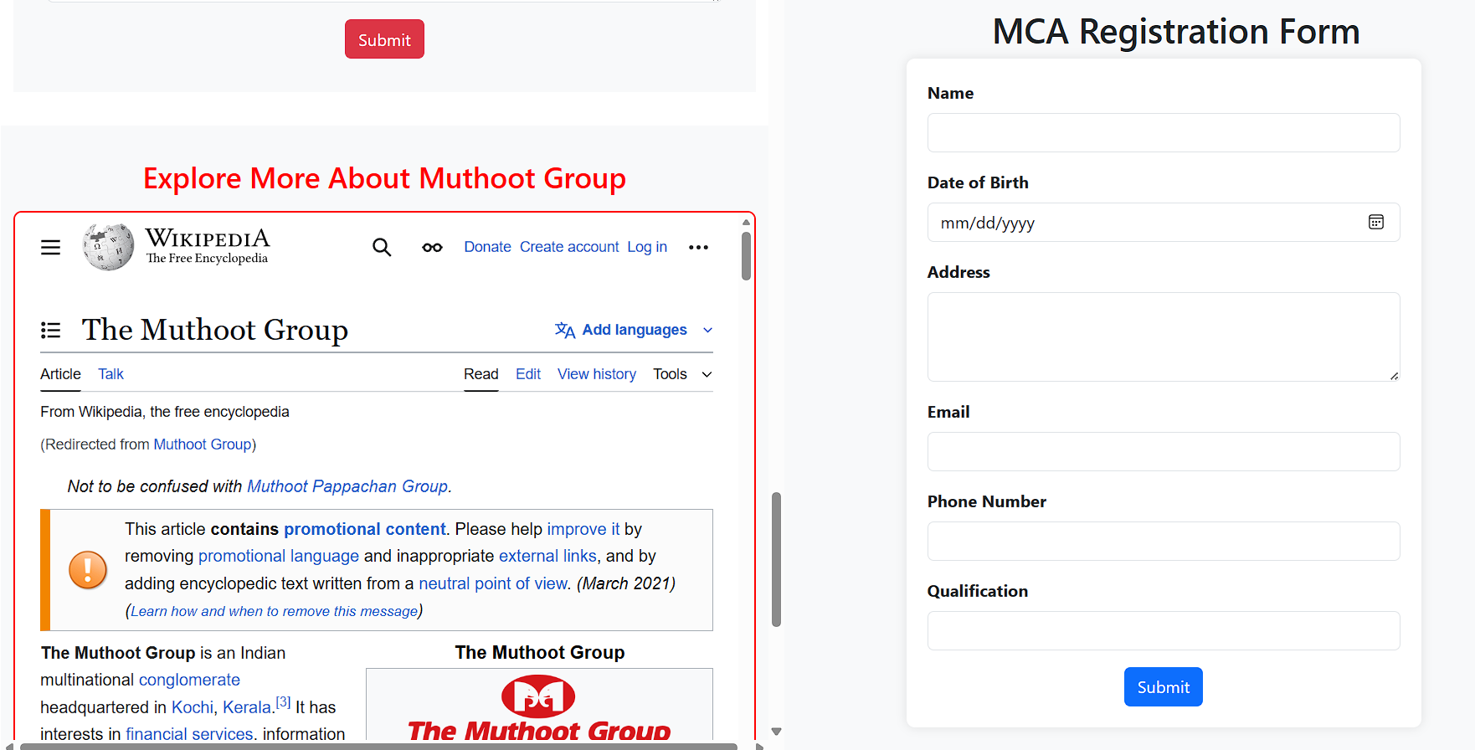

**Program # 3**

Create a webpage about your hometown and its tourist attractions using Html, and External, Internal, and inline CSS.   
The following elements should be included in the webpage.  
1. Html text formatting  
2. Links to Wikipedia pages for further references  
3. External, Internal, and Inline CSS  
4. CSS should include font colour, positioning, background colours, text alignment etc.  
5. Images of the hometown and its attractions.  
6. Usage of div elements for styling

**PROGRAM CODE:**

**hometown.html**

<!DOCTYPE html>

<html lang="en">

<head>

    <meta charset="UTF-8">

    <meta name="viewport" content="width=device-width, initial-scale=1.0">

    <title>Chottanikkara</title>

    <!-- Bootstrap CSS -->

  <link href="https://cdn.jsdelivr.net/npm/bootstrap@5.3.3/dist/css/bootstrap.min.css" rel="stylesheet">

<link rel="stylesheet" href="styles.css" />

    <style>

        .carousel-inner img {

            height: 500px;

            /* Set a fixed height for all images */

            object-fit: cover;

            width: 100%;

        }

    </style>

</head>

<body style="    background-color: whitesmoke;">

    <header>

        <nav class="navbar navbar-expand-lg navbar-light bg-light sticky-top">

            <div class="container-fluid">

                <a class="navbar-brand" href="#home">Chottanikkara</a>

                <button class="navbar-toggler" type="button" data-bs-toggle="collapse" data-bs-target="#navbarNav"

                    aria-controls="navbarNav" aria-expanded="false" aria-label="Toggle navigation">

                    <span class="navbar-toggler-icon"></span>

                </button>

                <div class="collapse navbar-collapse" id="navbarNav">

                    <ul class="navbar-nav">

                        <li class="nav-item">

                            <a class="nav-link active" aria-current="page" href="#home">Home</a>

                        </li>

                        <li class="nav-item">

                            <a class="nav-link" href="#about">About</a>

                        </li>

                        <li class="nav-item">

                            <a class="nav-link" href="#services">Services</a>

                        </li>

                        <li class="nav-item">

                            <a class="nav-link" href="#attach">Attraction</a>

                        </li>

                        <li class="nav-item">

                            <a class="nav-link" href="#contact">Contact</a>

                        </li>

                    </ul>

                </div>

            </div>

        </nav>

    </header>

    <section id="home" class="p-5">

        <div class="container-fluid p-0">

            <div class="text-center">

                <h2>Welcome to Chottanikkara</h2>

            </div>

            <div class="carousel slide w-100" id="carouselExampleIndicators" data-bs-ride="carousel">

                <div class="carousel-indicators">

                    <button type="button" data-bs-target="#carouselExampleIndicators" data-bs-slide-to="0" class="active" aria-current="true" aria-label="Slide 1"></button>

                    <button type="button" data-bs-target="#carouselExampleIndicators" data-bs-slide-to="1    aria-label="Slide 2"></button>

                    <button type="button" data-bs-target="#carouselExampleIndicators" data-bs-slide-to="2" aria-label="Slide 3"></button>

                </div>

                <div class="carousel-inner">

                    <div class="carousel-item active">

                      <img src="https://img.onmanorama.com/content/dam/mm/en/videos/travel/kerala/images/2025/4/28/1248.jpg"  class="d-block w-100" alt="Chottanikkara Temple Entrance">

                    </div>

                    <div class="carousel-item">

                        <img src="https://www.dtpcernakulam.com/uploads/picture_gallery/gallery_images/chottanikkara_temple-20230419131816183787.webp"    class="d-block w-100" alt="Chottanikkara Temple Main Sanctum">

                    </div>

                    <div class="carousel-item">

                        <img src=<https://www.nativeplanet.com/photos/929x523x90/2018/07/photo-91-163148-1.jpg> class="d-block w-100" alt="Chottanikkara Temple Festival">

                    </div>

                </div>

                <button class="carousel-control-prev" type="button" data-bs-target="#carouselExampleIndicators"

                    data-bs-slide="prev">

                    <span class="carousel-control-prev-icon" aria-hidden="true"></span>

                    <span class="visually-hidden">Previous</span>

                </button>

                <button class="carousel-control-next" type="button" data-bs-target="#carouselExampleIndicators"data-bs-slide="next">

                    <span class="carousel-control-next-icon" aria-hidden="true"></span>

                    <span class="visually-hidden">Next</span>

                </button>

            </div>

        </div>

        <div class="row">

            <div class="col-md-12">

                <div class="about">

                    <h2 class="text-center mt-4" id="about">About Chottanikkara</h2>

                    <p class="text-center"> Chottanikkara is a town and southern suburb of the city of Kochi, Kerala,India. In local administration, it is a panchayat which consists of Chottanikkara, Kanayannur,  Eruvely, Kureekkad, Vattukkunnu, Palace Square and Kottayathupara villages. Chottanikkara is    also a part of urban agglomeration of City of Kochi.The famous Chottanikkara temple is situated in town.[1] Kochi city buses are directly connected  to Chottanikkara, usually being the last stop. The Chottanikkara Government School stadium is  one of the largest stadiums in the Ernakulam District. The Chottanikkara Grama Panchayat was    selected as one of the best gram panchayats in the state by the Union Panchayati Raj

Ministry.[2] <br><br>Chottanikkara is a renowned temple town located in the Ernakulam district  of Kerala, India. It is famous for the Chottanikkara Bhagavathy Temple, dedicated to Goddess   Bhagavathy (a form of Durga). The temple is a significant pilgrimage site and attracts devotees  from all over the country. The temple is known for its unique rituals and festivals, including  the annual Navaratri festival, which is celebrated with great fervor.</p>

                </div>

            </div>

        </div>

</section>

<!-- Add Services Section Here -->

<section id="services" style="margin-top: 2rem; background-color: #f8f9fa; padding: 20px; border-radius: 8px;">

    <div class="container">

        <h2 class="text-center">Our Services</h2>

        <div class="row mt-4">

            <div class="col-md-4">

                <div class="card h-100">

                    <div class="card-body text-center">

                        <h5 class="card-title">Temple Tours</h5>

                        <p class="card-text">Experience guided tours of the famous Chottanikkara Bhagavathy Temple and other nearby attractions.</p>

                    </div>

                </div>

            </div>

            <div class="col-md-4">

                <div class="card h-100">

                    <div class="card-body text-center">

                        <h5 class="card-title">Accommodation</h5>

                        <p class="card-text">Find comfortable and affordable accommodations near the temple for a peaceful stay.</p>

                    </div>

                </div>

            </div>

            <div class="col-md-4">

                <div class="card h-100">

                    <div class="card-body text-center">

                        <h5 class="card-title">Local Guides</h5>

                        <p class="card-text">Hire knowledgeable local guides to explore the history and culture of Chottanikkara.</p>

                    </div>

                </div>

            </div>

        </div>

    </div>

</section>

    <section>

        <div class="row">

            <div class="col-md-12">

                <div class="attach">

                    <h2 class="text-center mt-4" id="attach">Attractions in Chottanikkara</h2>

                    <ul>

                        <li><strong>Chottanikkara Bhagavathy Temple:</strong> The main attraction of Chottanikkara, this temple is dedicated to Goddess Bhagavathy and is known for its unique rituals and festivals.

                        </li>

                        <li><strong>Vamanamoorthy Temple:</strong> Another significant temple in the area, dedicated to Lord Vamana, an incarnation of Lord Vishnu.

                        </li>

                        <li><strong>St. George's Church:</strong> A beautiful church located in Chottanikkara, known for its  architecture and serene environment.

                        </li>

                        <li><strong>Local Markets:</strong> Explore the local markets for traditional Kerala handicrafts,spices, and souvenirs.

                        </li>

                        <li><strong>Natural Beauty:</strong> Enjoy the scenic beauty of the surrounding hills and greenery,  perfect for nature walks and photography.

                        </li>

                    </ul>

                </div>

            </div>

        </div>

    </section>

    <section id="wikipedia" style="margin-top: 2rem; background-color: #f8f9fa; padding: 20px; border-radius: 8px;">

    <div class="container">

        <h2 class="text-center">Wikipedia</h2>

        <p style="text-align: justify;">

            Chottanikkara is a renowned temple town located in the Ernakulam district of Kerala, India. It is famous for the Chottanikkara Bhagavathy Temple, dedicated to Goddess Bhagavathy (a form of Durga). The temple is a significant pilgrimage site and attracts devotees from all over the country. The town is also known for its rich cultural heritage and serene environment.

        </p>

        <p style="text-align: center;">

            <a href="https://en.wikipedia.org/wiki/Chottanikkara" target="_blank" class="btn btn-danger">Read More on Wikipedia</a>

        </p>

    </div>

</section>

    <section>

        <div class="container-fluid">

            <div class="row">

                <div class="col-md-12">

                    <div class="temple">

                        <center>

                            <h2>Chottanikkara Bhagavathy Temple</h2>

                        </center>

                    </div>

                </div>

            </div>

            <div class="row">

                <div class="col-md-12">

                    <div class="detail"

                        style="background-color: antiquewhite; padding: 20px; border-radius: 8px; box-shadow: 0 4px 8px rgba(0, 0, 0, 0.1);">

                        <p>Chottanikkara Bhagavathy Temple is one of the most famous temples in Kerala, dedicated to  Goddess Bhagavathy, a form of Durga. The temple is renowned for its unique rituals and  festivals, attracting thousands of devotees every year. The temple complex architectural marvel, showcasing traditional Kerala style architecture with intricate wood carvings and murals.  The temple is particularly known for its healing powers, with many devotees believing that      the goddess has the ability to cure mental illnesses and ailments. The temple's annual  Navaratri festival is celebrated with great fervor, featuring elaborate rituals, cultural  performances, and a grand procession. The temple is not only a spiritual center but also a   cultural hub, preserving and promoting the rich traditions of Kerala.</p>

                    </div>

                </div>

            </div>

            <div class="row">

                <div class="col-md-12">

                    <div class="photogallary" style="    border-radius: 50px;">

                        <h2 class="text-center mt-4">Photo Gallery</h2>

                        <div class="row">

                            <div class="col-md-4 mb-3">

                                <img src="https://www.dtpcernakulam.com/uploads/picture_gallery/gallery_images/chottanikkara_temple-20230419131816183787.webp"  class="img-fluid" alt="Chottanikkara Temple Entrance">

                            </div>

                            <div class="col-md-4 mb-3">

                                <img src="https://th.bing.com/th/id/R.6b38b429859c7de7d6ebc9bc87249dac?rik=UL0070yQLixdug&riu=http%3a%2f%2f3.bp.blogspot.com%2f-HApdG728qks%2fTyTYGsKhvuI%2fAAAAAAAAC24%2fSdmU_HemNmA%2fs1600%2fchottanikkaratemple%2b%2525281%252529.jpg&ehk=vJigUfcS6ysudXRZaEJxHUk7b5LJLbeJAPn3DKutyJE%3d&risl=&pid=ImgRaw&r=0"class="img-fluid" alt="Chottanikkara Temple Main Sanctum">

                            </div>

                            <div class="col-md-4 mb-3">

                                <img src="https://cultureandheritage.org/wp-content/uploads/2024/02/image-80.png"    class="img-fluid" alt="Chottanikkara Temple Festival">

                            </div>

                        </div>

                    </div>

                </div>

            </div>

            <div class="row" style="background-color:whitesmoke; margin-top: 2rem;">

                <div class="col-md-12">

                    <div class="church" style="margin-top: 2rem;">

                        <center>

                            <h2>St. Johns Jacobite Syrian Church , Kanniattunirappu</h2>

                        </center>

                    </div>

                </div>

            </div>

            <div class="row" style="margin-bottom: 2rem;">

                <div class="col-md-12">

                    <div class="detail"

                        style="background-color: antiquewhite; padding: 20px; border-radius: 8px; box-shadow: 0 4px 8px rgba(0, 0, 0, 0.1);">

                        <p>St. John's Orthodox Syrian Church, also known as Kanniattunirappu Palli is a church part of  the Kandanad Diocese of Jacobite Syrian Church . The church is located beside the  Chottanikkara Vandippetta Road within the village of Thiruvaniyoor, in the Indian state of    Kerala. is a beautiful and historic church known for its stunning architecture and serene environment. The church is dedicated to St. George, a revered Christian martyr, and serves     as a significant place of worship for the local Christian community. The church's

  architecture features traditional Kerala style elements combined with colonial influences,

    creating a unique and picturesque structure. The church is surrounded by lush greenery,

    providing a peaceful atmosphere for prayer and reflection. It also hosts various religious

      festivals and events throughout the year, attracting devotees and visitors alike. St.

    George's Church is not only a spiritual center but also a cultural landmark in

    Chottanikkara, contributing to the town's rich heritage.</p>

</div>

                </div>

            </div>

            <div class="row">

                <div class="col-md-12">

                    <div class="photogallary">

                        <h2 class="text-center mt-4">Photo Gallery</h2>

                        <div class="row">

                            <div class="col-md-4 mb-3">

                                <img src="https://yt3.googleusercontent.com/bgqzpDyWH1ewmfo9_ifaKF_g47viyr2FqIId5vuee9rgdRZaZZ92FdpGubeOgDOhklJyXD7oBgk=s900-c-k-c0x00ffffff-no-rj"  class="img-fluid" alt="St. George's Church Exterior">

                            </div>

                            <div class="col-md-4 mb-3">

                                <img src="https://tse3.mm.bing.net/th/id/OIP.pntRHxeVyAp1T-TPkqo3QAHaEK?rs=1&pid=ImgDetMain&o=7&rm=3"  class="img-fluid" alt="St. George's Church Interior">

                            </div>

                            <div class="col-md-4 mb-3">

                                <img src="https://th.bing.com/th/id/R.88fe3a8ecab7850cf0fca0c1786cea54?rik=unPMcehVu5a74w&riu=http%3a%2f%2fphotos.wikimapia.org%2fp%2f00%2f01%2f06%2f75%2f67_big.jpg&ehk=qwD7NKXkkysIOlplQtg%2b4rScgHPxh%2fXSbHAgWSynMLM%3d&risl=&pid=ImgRaw&r=0"      class="img-fluid" alt="St. George's Church Altar">

                            </div>

                        </div>

                    </div>

                </div>

            </div>

        </div>

    </section>

    <footer>

        <div class="container-fluid bg-danger text-white text-center p-4" id="contact">

            <div class="row">

                <div class="col-md-4">

                    <h5>Contact Us</h5>

                    <p>Phone: +91 9876543210</p>

                    <p>Email: info@chottanikkara.com</p>

                </div>

                <div class="col-md-4">

                    <h5>Address</h5>

                    <p>Chottanikkara, Ernakulam, Kerala, India</p>

                    <p>PIN: 682312</p>

                </div>

                <div class="col-md-4">

                    <h5>Follow Us</h5>

                    <a href="#" class="text-white me-3">Facebook</a>

                    <a href="#" class="text-white me-3">Twitter</a>

                    <a href="#" class="text-white">Instagram</a>

                </div>

            </div>

            <div class="row mt-3">

                <div class="col-md-12">

                    <p>&copy; 2024 Chottanikkara Tourism. All rights reserved.</p>

                </div>

            </div>

        </div>

    </footer>

    <!-- Bootstrap JS Bundle (includes Popper) -->

    <script src="https://cdn.jsdelivr.net/npm/bootstrap@5.3.3/dist/js/bootstrap.bundle.min.js"></script>

</body>

</html>

**Style.css**

        .about {

            margin-top: 20px;

            background-color: antiquewhite;

        }

        .photogallary {

            margin-top: 20px;

            padding: 20px;

            background-color: #f8f9fa;

            /* Light background for better contrast */

            border-radius: 8px;

            /* Rounded corners */

            box-shadow: 0 4px 8px rgba(0, 0, 0, 0.1);

            /* Subtle shadow for depth */

        }

        .photogallary h2 {

            font-size: 2rem;

            font-weight: bold;

            color: #333;

            /* Darker text for better readability */

            margin-bottom: 20px;

        }

        .photogallary img {

            border-radius: 8px;

            /* Rounded corners for images */

            transition: transform 0.3s ease, box-shadow 0.3s ease;

            /* Smooth hover effect */

        }

        .photogallary img:hover {

            transform: scale(1.05);

            /* Slight zoom effect on hover */

            box-shadow: 0 8px 16px rgba(0, 0, 0, 0.2);

            /* Add shadow on hover */

        }

**Output**

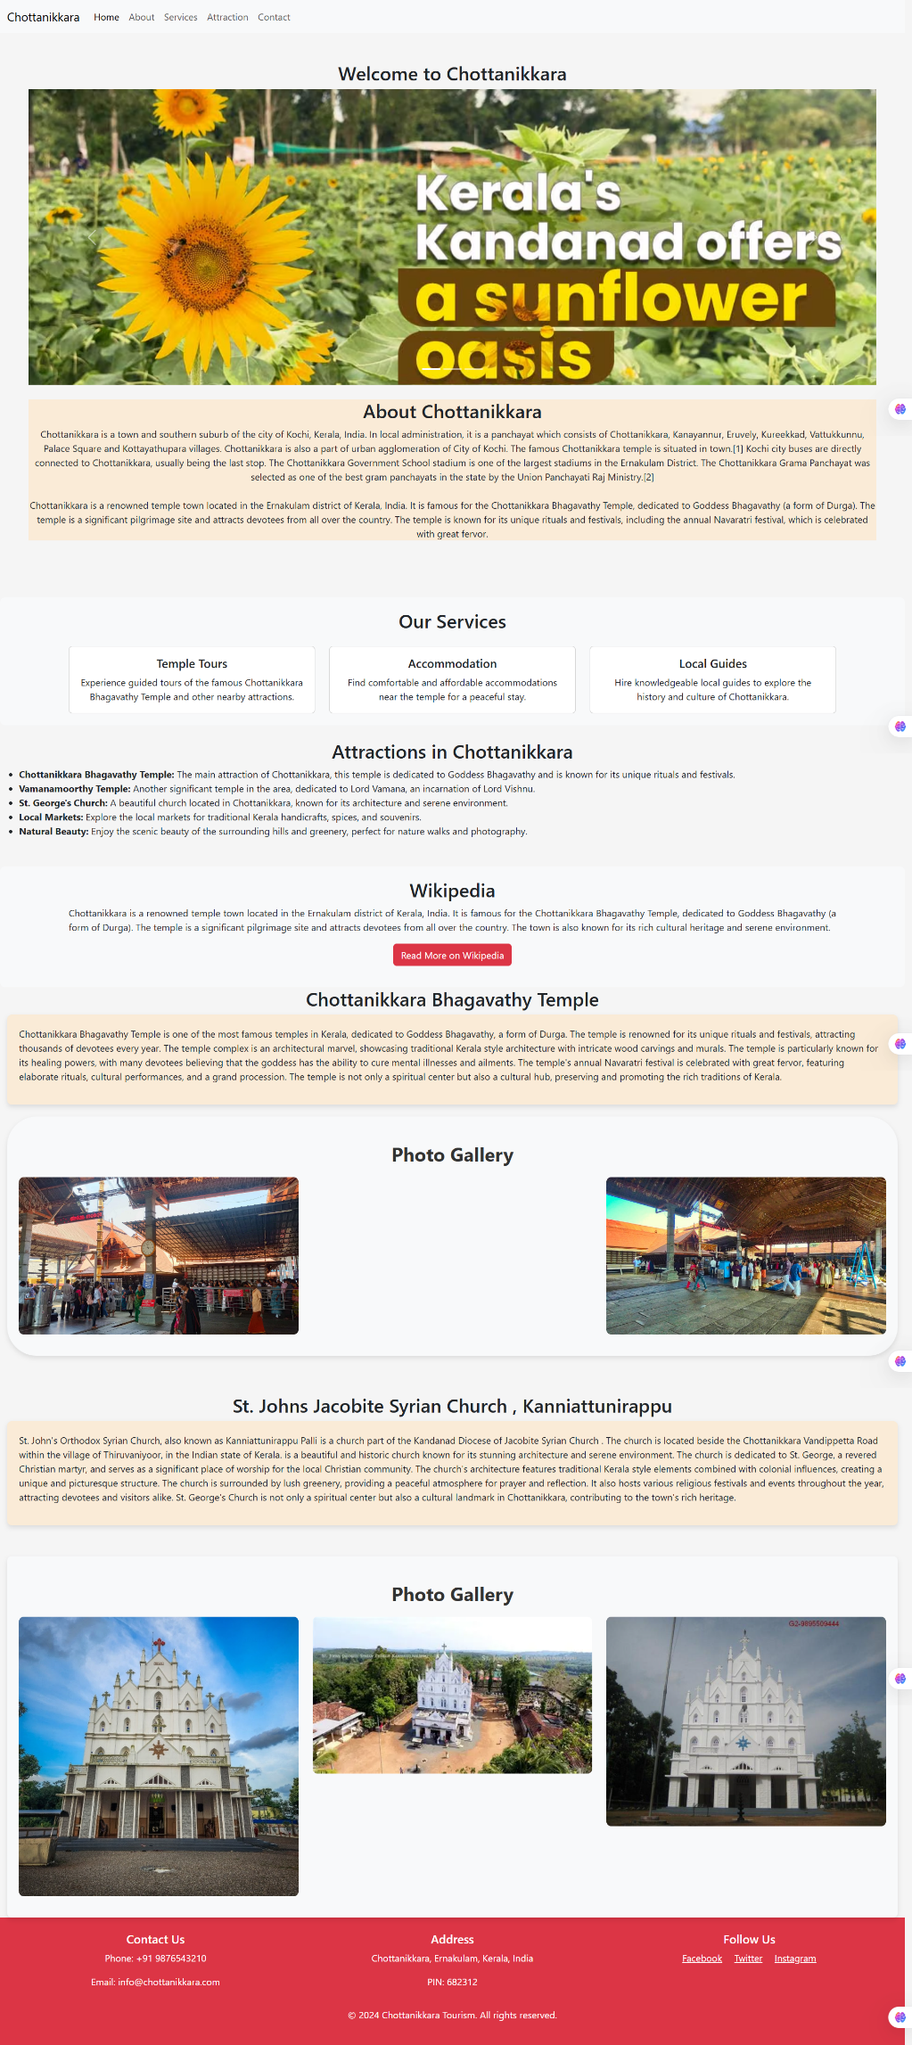

**Program # 4**

Create MITS college Website with the help of frames, style sheets, background colours, images, tables, and lists. Create multiple webpages which are easily navigable by hyperlinks. Apply style sheets as well as floating, mixed, and navigation frames to design the webpages.

**PROGRAM CODE:**

**Muthootclg.html**

<!DOCTYPE html>

<html lang="en">

<head>

<meta charset="UTF-8">

<meta name="viewport" content="width=device-width, initial-scale=1.0">

<title>MITS</title>

<!-- Bootstrap CSS -->

<link href="https://cdn.jsdelivr.net/npm/bootstrap@5.3.3/dist/css/bootstrap.min.css"

rel="stylesheet">

<style>

.image {

margin-left: 2rem;

}

.righthe {

margin-right: 8rem;

}

.navbar-nav .nav-link {

color: white;

margin-left: 5rem;

align-items: center;

}

.carousel-inner img {

height: 500px;

/* Set a fixed height for all images */

object-fit: cover;

/* Ensures the image covers the area while maintaining aspect ratio */

}

</style>

</head>

<body>

<header>

<nav class="navbar navbar-expand-lg navbar">

<div class="container-fluid">

<div class="row">

<div class="col-md-6">

<div class="image">

<img src="https://mgmits.ac.in/wp-content/themes/muthoot/images/MITS-LOGO-

NEW.jpeg" alt=""></div>

</div>

<div class="col-md-6">

<div class="righthe">

<p>Affiliated to APJ Abdul Kalam Technological University Approved by AICTE</p>

<div class="contact" style="color:red;">

<p>Contact: 0484-2803030</p>

<p>Email: info@mgits.ac.in</p>

</div>

</div>

</div>

</div>

<hr>

</div>

</nav>

</header>

<!-- Navigation Section -->

<section>

<nav class="navbar navbar-expand-lg navbar navbar-light bg-red" style="background-color:

#ff0000;">

<div class="container-fluid">

<!-- Toggler Button for Mobile View -->

<button class="navbar-toggler" type="button" data-bs-toggle="collapse" data-bs-

target="#navbarNav" aria-controls="navbarNav" aria-expanded="false" aria-label="Toggle navigation">

<span class="navbar-toggler-icon"></span>

</button>

<!-- Navbar Links -->

<div class="collapse navbar-collapse justify-content-between " style="color:red;"

id="navbarNav">

<ul class="navbar-nav">

<li class="nav-item">

<a class="nav-link" href="#Home">Home</a>

</li>

<li class="nav-item">

<a class="nav-link" href="#aboutcollege">About College</a>

</li>

<li class="nav-item">

<a class="nav-link" href="#btech">Btech</a>

</li>

<li class="nav-item">

<a class="nav-link" href="#mca">MCA</a>

</li>

<li class="nav-item">

<a class="nav-link" href="#management">Management</a>

<li class="nav-item">

<a class="nav-link" href="#contact">Contact</a>

</li>

</ul>

</div>

</div>

</nav>

</section>

<section id="Home">

<div class="containter">

<div class="row">

<div class="col-md-12">

<carsousel class="carousel slide" data-bs-ride="carousel"

id="carouselExampleIndicators">

<div class="carousel-indicators">

<button type="button" data-bs-target="#carouselExampleIndicators" data-bs-

slide-to="0"class="active" aria-current="true" aria-label="Slide 1"></button>

<button type="button" data-bs-target="#carouselExampleIndicators" data-bs-

slide-to="1"aria-label="Slide 2"></button>

<button type="button" data-bs-target="#carouselExampleIndicators" data-bs-

slide-to="2"baria-label="Slide 3"></button>

</div>

<div class="carousel-inner">

<div class="carousel-item active">

<img src="https://mgmits.ac.in/wp-content/uploads/2019/05/mits-1024x368.jpg" class="d-block w-100 h-50" alt="">

</div>

<div class="carousel-item">

<img src="https://mgmits.ac.in/wp-content/uploads/2019/07/resized020.png"class="d-block w-100" alt="...">

</div>

<div class="carousel-item">

<img src=<https://th.bing.com/th/id/R.04cc914d5b9aac1b6945b498a6d0072e?rik=OEABI8WPXPo3zw&riu=http%3a%2f%2fmgmits.ac.in%2fwpcontent%2fuploads%2f2019%2f07%2fnew017.jpg&ehk=40BCnXD8UWU8pIxml5fxeQlPnNvoX0LRrHxRWCVvPpA%3d&risl=&pid=ImgRaw&r=0> class="d-block w-100" alt="...">

</div>

</div>

<button class="carousel-control-prev" type="button" data-bs-

target="#carouselExampleIndicators"data-bs-slide="prev">

<span class="carousel-control-prev-icon" aria-hidden="true"></span>

<span class="visually-hidden">Previous</span>

</button>

<button class="carousel-control-next" type="button" data-bs-target="#carouselExampleIndicators"

data-bs-slide="next">

<span class="carousel-control-next-icon" aria-hidden="true"></span>

<span class="visually-hidden">Next</span>

</button>

</div>

</div>

</div>

</section>

<section id="aboutcollege">

<div class="container-fluid" style="background-color: #f8f9fa; padding: 2rem 0;">

<div class="row">

<div class="col-md-12">

<div class="about" style="background-color: #ff0000;">

<div class="text-center mb-4" style="margin-top: 2rem; color:white; background-

color:red;">

<h2>About College</h2>

</div>

</div>

</div>

<div class="row">

<div class="col-md-12">

<div class="muthootabout">

<p style="margin-left: 2rem; margin-right:2rem; text-align: justify;">Muthoot Institute of Technology and Science (MITS) is a premier engineering college located in Kochi, Kerala,India. Established in 2010, MITS is part of the Muthoot Group, a renowned

Business conglomerate with diverse interests including finance, real estate, and hospitality. The college is affiliated with the APJ Abdul Kalam Technological University and is Approved by the All India Council for Technical Education (AICTE). MITS offers undergraduate and postgraduate programs in various engineering disciplines, including Computer Science,Electronics and Communication, Mechanical, and Civil Engineering. The institution is committed to providing quality education, fostering innovation, and promoting researchamong its students and faculty. With state-of-the-art infrastructure, experienced faculty, and a focus on holistic development, MITS aims to nurture skilled professionals who can contribute effectively to the industry and society. The college also emphasizes industry collaboration, internships, and placements to ensure that students are well-prepared for their careers.</p>

</div>

</div>

</div>

</div>

</div>

</section>

<section>

<div class="container-fluid">

<div class="row">

<div class="col-md-12">

<div class="btech" id="btech" style="background-color: #ff0000; color:white;">

<ul>

<li>

<h2>Btech</h2>

</li>

</ul>

</div>

</div>

</div>

<div class="row">

<div class="col-md-12">

<div class="btechabout" style="margin-top: 2rem;">

<p> The Btech course we Offers </p>

<ol>

<li>Mechanical</li>

<li>Civil</li>

<li>EEE</li>

<li>Cyber</li>

</ol>

</div>

</div>

</div>

<div class="row" id="mca">

<div class="col-md-12">

<div class="mca" style="background-color: #ff0000; color:white">

<ul>

<li>

<h2>MCA</h2>

</li>

</ul>

</div>

<div class="mcaabout">

<p style="margin-left: 2rem; margin-right: 2rem; text-align: justify;">

The Master of Computer Applications (MCA) program at Muthoot Institute ofTechnology and Science (MITS) is designed to provide students with a strong foundation in computer Science and applications. The program focuses on equipping students with the technical skills and knowledge required to excel in the IT industry. With a curriculum that blends theoretical concepts and practical applications, the MCA program emphasizes software development, database management, web technologies, and emerging fields like artificial intelligence and data science.

</p>

<p style="margin-left: 2rem; margin-right: 2rem; text-align: justify;">

The program is supported by experienced faculty, state-of-the-art laboratories, and Industry collaborations to ensure students are well-prepared for their careers. MITS also Provides opportunities for internships, live projects, and placements with leading IT companies. The MCA program aims to nurture professionals who can contribute effectively to the ever-evolving technology landscape.

</p>

</div>

</div>

</div>

<div class="row">

<div class="col-md-12">

<div class="mca">

<h4>Apply Online For Mca Admission</h4>

<a href="mcareg.html">Click Here </a>

</div>

</div>

</div>

</div>

</section>

<section id="management">

<div class="container-fluid" style=" margin-top: 2rem;">

<div class="row" style="background-color: #ff0000;">

<div class="col-md-12">

<div class="management" style="text-align: center;color: #f8f9fa;">

<h2>Management</h2>

</div>

</div>

</div>

<div class="row">

<div class="col-md-12">

<div class="mutimg" style="margin-top: 2rem;">

<center> <img src="https://muthootgroup.com/assets/muthoot/img/mtg.png"

style="height: 10rem;">

</center>

</div>

</div>

</div>

</div>

</div>

</section>

<section id="contact">

<div class="container-fluid" style="margin-top: 2rem;">

<div class="row">

<div class="col-md-12">

<div class="contact" style="background-color: #f8f9fa; padding: 2rem;">

<div class="tt" style="background-color: red;color: #f8f9fa;"> <h2 class="text-center

mb-4">Contact Us</h2></div>

<form action="" method="post">

<div class="mb-3">

<label for="name" class="form-label">Full Name</label>

<input type="text" class="form-control" id="name" name="name"

placeholder="Enter your full name" required>

</div>

<div class="mb-3">

<label for="email" class="form-label">Email Address</label>

<input type="email" class="form-control" id="email" name="email"

placeholder="Enter your email" required>

</div>

<div class="mb-3">

<label for="phone" class="form-label">Phone Number</label>

<input type="tel" class="form-control" id="phone" name="phone"

placeholder="Enter your phone number" required>

</div>

<div class="mb-3">

<label for="message" class="form-label">Message</label>

<textarea class="form-control" id="message" name="message" rows="4"

placeholder="Enter your message" required></textarea>

</div>

<div class="text-center">

<button type="submit" class="btn btn-danger">Submit</button>

</div>

</form>

</div>

</div>

</div>

</div>

</section>

<!-- Iframe Section -->

<section id="iframe-section" style="margin-top: 2rem; background-color: #f8f9fa; padding: 2rem

0;">

<div class="container-fluid">

<div class="row">

<div class="col-md-12">

<h2 class="text-center" style="color: #ff0000; margin-bottom: 1rem;">Explore More

About Muthoot Group</h2>

<iframe src="https://en.wikipedia.org/wiki/Muthoot_Group"

title="Muthoot Group Wikipedia"style="width: 100%; height: 600px; border: 2px solid #ff0000; border-radius: 8px;">

</iframe>

</div>

</div>

</div>

</section>

<footer style="background-color: #ff0000; color: white; padding: 1rem 0;">

<div class="container-fluid">

<div class="row">

<div class="col-md-4 text-center">

<h5>Contact Us</h5>

<p>Phone: 0484-2803030</p>

<p>Email: info@mgits.ac.in</p>

</div>

<div class="col-md-4 text-center">

<h5>Address</h5>

<p>Muthoot Institute of Technology and Science</p>

<p>Varikoli P.O., Ernakulam, Kerala, India</p>

</div>

<div class="col-md-4 text-center">

<h5>Follow Us</h5>

<a href="#" style="color: white; margin-right: 10px;">Facebook</a>

<a href="#" style="color: white; margin-right: 10px;">Twitter</a>

<a href="#" style="color: white;">LinkedIn</a>

</div>

</div>

<div class="row mt-3">

<div class="col-md-12 text-center">

<p>&copy; 2025 Muthoot Institute of Technology and Science. All Rights Reserved.</p>

</div>

</div></div>

</footer>

<!-- Bootstrap JS Bundle (includes Popper) -->

<script

src="https://cdn.jsdelivr.net/npm/bootstrap@5.3.3/dist/js/bootstrap.bundle.min.js"></script>

</body>

</html>

**Mcareg.html**

<!DOCTYPE html>

<html lang="en">

<head>

<meta charset="UTF-8">

<meta name="viewport" content="width=device-width, initial-scale=1.0">

<title>Mca Registartion</title>

<!-- Bootstrap CSS -->

<link href="https://cdn.jsdelivr.net/npm/bootstrap@5.3.3/dist/css/bootstrap.min.css"

rel="stylesheet">

<style>

body {

background-color: #f8f9fa;

}

.form {

background: #fff;

padding: 20px;

border-radius: 8px;

box-shadow: 0 0 10px rgba(0, 0, 0, 0.1);

}

.form-label {

font-weight: bold;

}

</style>

</head>

<body>

<section>

<div class="container ">

<div class="row">

<div class="col-md-12">

<h1 class="text-center mt-4">MCA Registration Form</h1>

</div>

<div class="row">

<div class="col-md-12">

<div class="form">

<form action="" method="post">

<div class="mb-3">

<label for="name" class="form-label">Name</label>

<input type="text" class="form-control" id="name" name="name"required>

</div>

<div class="mb-3">

<label for="dob" class="form-label">Date of Birth</label>

<input type="date" class="form-control" id="dob" name="dob" required>

</div>

<div class="mb-3">

<label for="address" class="form-label">Address</label>

<textarea class="form-control" id="address" name="address" rows="3"required></textarea>

</div>

<div class="mb-3">

<label for="email" class="form-label">Email</label>

<input type="email" class="form-control" id="email" name="email"required>

</div>

<div class="mb-3">

<label for="phone" class="form-label">Phone Number</label>

<input type="tel" class="form-control" id="phone" name="phone"required>

</div>

<div class="mb-3">

<label for="qualification" class="form-label">Qualification</label>

<input type="text" class="form-control" id="qualification" name="qualification" required>

</div>

<center><button type="submit" class="btn btn-primary">Submit</button></center>

</form>

</div>

</div>

</div>

</div>

</div>

</section>

<!-- Bootstrap JS Bundle (includes Popper) -->

<script

src="https://cdn.jsdelivr.net/npm/bootstrap@5.3.3/dist/js/bootstrap.bundle.min.js"></script>

</body>

</html>

**Output**

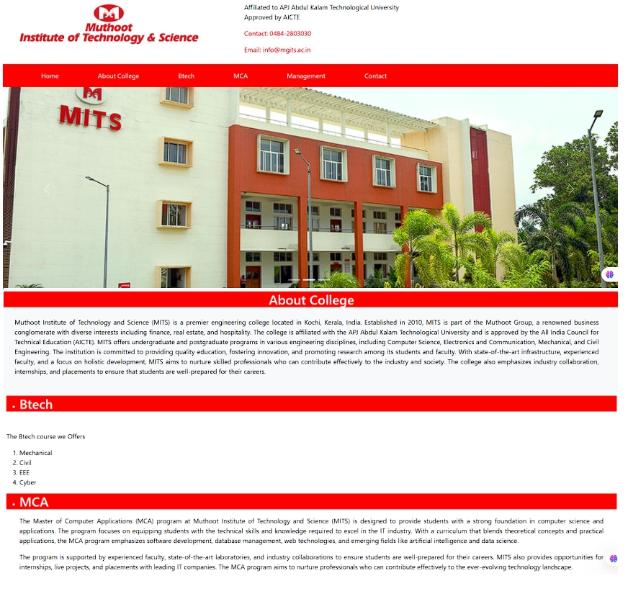

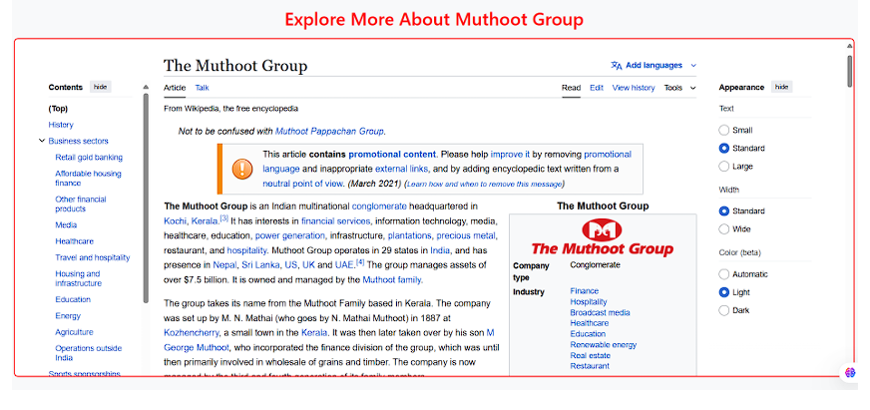

**Program # 5**

Apply positioning methods of elements on a webpage with div elements and their corresponding classes using two external stylesheets. Compare the output with absolute, and relative positioning of div elements.

.

**PROGRAM CODE:**

**Position.html**

<!DOCTYPE html>

<html lang="en">

<head>

<meta charset="UTF-8">

<meta name="viewport" content="width=device-width, initial-scale=1.0">

<title>Positioning Example</title>

<!-- Link to External Stylesheets -->

<link rel="stylesheet" href="relative.css">

<link rel="stylesheet" href="absolute.css">

</head>

<body>

<h1 class="text-center">Positioning Methods: Relative vs Absolute</h1>

<!-- Relative Positioning -->

<div class="relative-container">

<div class="relative-box">Relative Box</div>

</div>

<!-- Absolute Positioning -->

<div class="absolute-container">

<div class="absolute-box">Absolute Box</div>

</div>

</body>

</html>

**Relative.css**

/* relative.css */

body {

font-family: Arial, sans-serif;

margin: 0;

padding: 0;

background-color: #f8f9fa;

}

.text-center {

text-align: center;

margin: 20px 0;

}

.relative-container {

position: relative;

width: 300px;

height: 200px;

margin: 20px auto;

background-color: #d1e7dd;

border: 2px solid #0f5132;

}

.relative-box {

position: relative;

top: 20px;

left: 20px;

width: 100px;

height: 100px;

background-color: #0d6efd;

color: white;

display: flex;

align-items: center;

justify-content: center;

border-radius: 8px;

}

**Absolute.css**

/* absolute.css */

.absolute-container {

position: relative;

width: 300px;

height: 200px;

margin: 20px auto;

background-color: #f8d7da;

border: 2px solid #842029;

}

.absolute-box {

position: absolute;

top: 20px;

left: 20px;

width: 100px;

height: 100px;

background-color: #dc3545;

color: white;

display: flex;

align-items: center;

justify-content: center;

border-radius: 8px;

}

**Output**

**Lab Cycle 2**

**CO2: Learn and design client-side validation using scripting languages.**

**Program # 6**

Create a HTML page to explain the use of various predefined functions in a string and math  
object in java script.

**PROGRAM CODE:**

**jsfunction.html**

<!DOCTYPE html>

<html lang="en">

<head>

    <meta charset="UTF-8">

    <meta name="viewport" content="width=device-width, initial-scale=1.0">

    <title>Dynamic Functions</title>

    <!-- Bootstrap CSS -->

    <link href="https://cdn.jsdelivr.net/npm/bootstrap@5.3.3/dist/css/bootstrap.min.css" rel="stylesheet">

</head>

<body>

    <section>

        <div class="container-fluid">

            <div class="row">

                <div class="col-md-6">

                    <h1>String Functions</h1>

                    <div class="mb-3">

                        <label for="stringInput" class="form-label">Enter a String:</label>

                        <input type="text" id="stringInput" class="form-control" placeholder="Enter a string">

                    </div>

                    <button class="btn btn-primary mb-3" onclick="processString()">Show String Functions</button>

                    <p id="len"></p>

                    <p id="slice"></p>

                    <p id="sub"></p>

                    <p id="rep"></p>

                    <p id="con"></p>

                    <p id="upper"></p>

                </div>

                <div class="col-md-6">

                    <h1>Math Functions</h1>

                    <div class="mb-3">

                        <label for="numberInput" class="form-label">Enter a Number:</label>

                        <input type="number" id="numberInput" class="form-control" placeholder="Enter a number">

                    </div>

                    <button class="btn btn-primary mb-3" onclick="processMath()">Show Math Functions</button>

                    <p id="ceil"></p>

                    <p id="floor"></p>

                    <p id="trunc"></p>

                    <p id="sign"></p>

                    <p id="pow"></p>

                    <p id="sqrt"></p>

                    <p id="abs"></p>

                    <p id="log"></p>

                    <p id="random"></p>

                </div>

            </div>

        </div>

    </section>

    <script>

        // Function to process string input

        function processString() {

            const input = document.getElementById('stringInput').value;

           if (!input) {

                alert("Please enter a string.");

                return;

            }

            document.getElementById('len').innerHTML = `Length: ${input.length}`;

            document.getElementById('slice').innerHTML = `Slice (0, 5): ${input.slice(0, 5)}`;

            document.getElementById('sub').innerHTML = `Substring (0, 5): ${input.substring(0, 5)}`;

            document.getElementById('rep').innerHTML = `Replace 'a' with 'X': ${input.replace(/a/g, 'X')}`;

            document.getElementById('con').innerHTML = `Concat with ' World': ${input.concat(' World')}`;

            document.getElementById('upper').innerHTML = `Uppercase: ${input.toUpperCase()}`;

        }

        // Function to process math input

        function processMath() {

            const input = parseFloat(document.getElementById('numberInput').value);

            if (isNaN(input)) {

                alert("Please enter a valid number.");

                return;

            }

            document.getElementById('ceil').innerHTML = `Ceil: ${Math.ceil(input)}`;

            document.getElementById('floor').innerHTML = `Floor: ${Math.floor(input)}`;

            document.getElementById('trunc').innerHTML = `Trunc: ${Math.trunc(input)}`;

            document.getElementById('sign').innerHTML = `Sign: ${Math.sign(input)}`;

            document.getElementById('pow').innerHTML = `Power (input^2): ${Math.pow(input, 2)}`;

            document.getElementById('sqrt').innerHTML = `Square Root: ${Math.sqrt(input)}`;

            document.getElementById('abs').innerHTML = `Absolute: ${Math.abs(input)}`;

            document.getElementById('log').innerHTML = `Logarithm: ${Math.log(input)}`;

            document.getElementById('random').innerHTML = `Random (0-1): ${Math.random()}`;

        }

    </script>

    <!-- Bootstrap JS Bundle (includes Popper) -->

    <script src="https://cdn.jsdelivr.net/npm/bootstrap@5.3.3/dist/js/bootstrap.bundle.min.js"></script>

</body>

</html>

**Output**

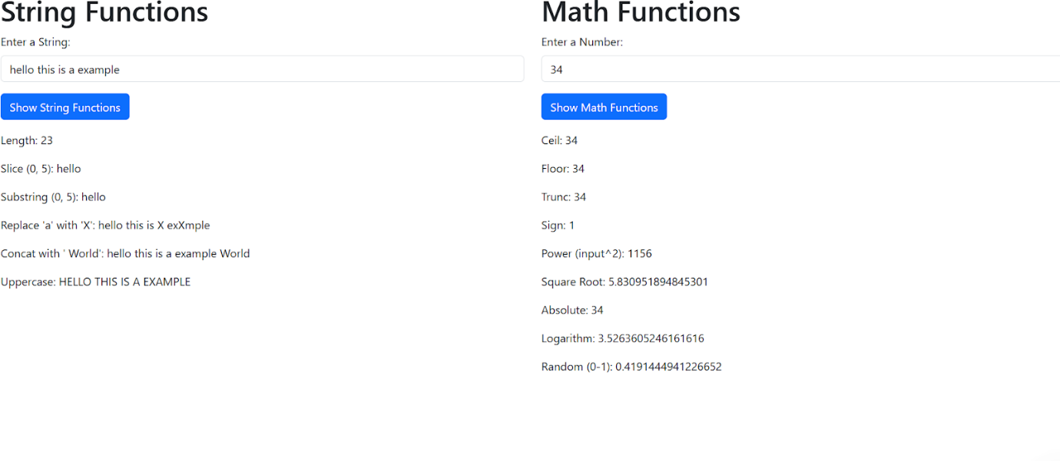

**Program # 7**

Generate the calendar using JavaScript code by getting the year from the user.

**PROGRAM CODE:**

**Calander.html**

<html>

<head>

<title>Calendar in JS</title>

<link rel="stylesheet" type="text/css" href="calStyle.css">

</head>

<body>

<h2><center>CALENDAR USING JAVASCRIPT<center></h2>

<br/>

<script src="calScript.js"></script>

Year: <input id="y" type="number" name="year"><br/><br/>

Month:<input id="m" type="number" name="month"><br/><br/>

<input type="button" value="Calendar" onclick="createCalendar()"> <br/>

<br/>

<div id="cal"></div>

</body>

</html>

**calScript.js**

function createCalendar() {

    var year = document.getElementById("y").value;

    var month = document.getElementById("m").value;

   let mon = month - 1; // months in JS are 0..11, not 1..12

    let d = new Date(year, mon);

    let table = `<table>

        <tr>

           <th>SUN</th><th>MON</th><th>TUE</th><th>WED</th>

            <th>THU</th><th>FRI</th><th>SAT</th>

        </tr>

        <tr>`;

    // Blank cells for the first row from Sunday till the first day of the month

    for (let i = 0; i < d.getDay(); i++) {

        table += '<td></td>';

    }

    // <td> with actual dates

    while (d.getMonth() == mon) {

        table += '<td>' + d.getDate() + '</td>';

        if (d.getDay() % 7 == 6) { // Saturday, last day of week - newline

            table += '</tr><tr>';

        }

        d.setDate(d.getDate() + 1);

    }

    // Add spaces after the last days of the month to fill the table row

    if (d.getDay() != 0) {

        for (let i = d.getDay(); i < 7; i++) {

            table += '<td></td>';

        }

    }

  // Close the table

    table += '</tr></table>';

    document.getElementById("cal").innerHTML = table;

}

**calStyle.css**

table {

border-collapse: collapse;

}

td,

th {

border: 1px solid black;

padding: 3px;

text-align: center;

}

th {

font-weight: bold;

background-color: #E6E6E6;

}

**Output**

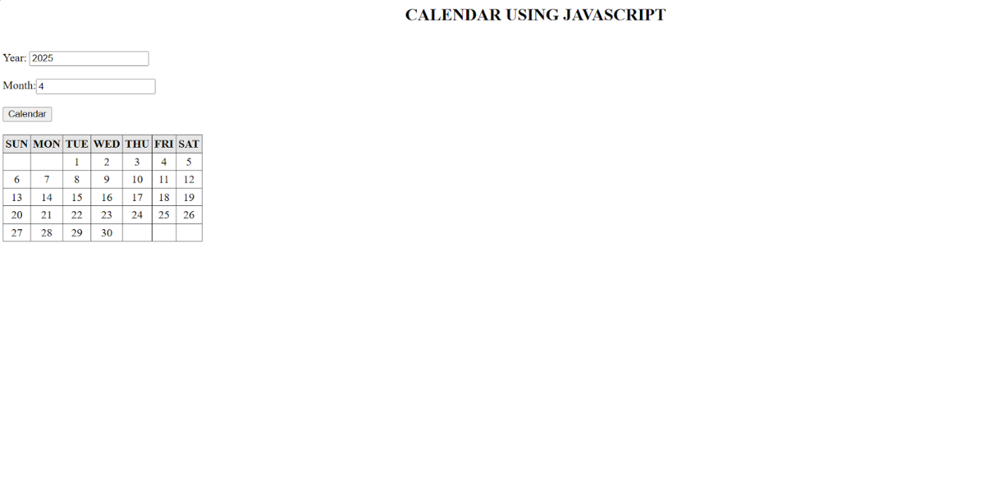

**Program # 8**

Create a program using the JavaScript Event Listener to add multiple events on the same button.

**PROGRAM CODE:**

**Index.html**

<!DOCTYPE html>

<html lang="en">

<head>

    <meta charset="UTF-8">

    <meta name="viewport" content="width=device-width, initial-scale=1.0">

    <title>Document</title>

    <link href="https://cdn.jsdelivr.net/npm/bootstrap@5.3.3/dist/css/bootstrap.min.css" rel="stylesheet">

    <link rel="stylesheet" href="styles.css">

    <style>

.demo1 {

    padding: 10px;

    border: 1px solid #ddd;

    border-radius: 5px;

    margin-top: 10px;

}

.mouseover {

    color: blue;

    font-weight: bold;

}

.mouseout {

    color: red;

    font-style: italic;

}

.click {

    color: green;

    text-decoration: underline;

}

.dblclick {

    color: purple;

    font-weight: bold;

    font-style: italic;

}

.mousedown {

    color: orange;

    font-size: 1.2rem;

}

.mouseup {

    color: teal;

    font-size: 1.2rem;

}

.focus {

    color: darkblue;

    background-color: #e0f7fa;

    padding: 5px;

    border-radius: 3px;

}

.blur {

    color: darkred;

    background-color: #ffebee;

    padding: 5px;

    border-radius: 3px;

}

    </style>

</head>

<body>

   <div class="container-fluid">

    <div class="row">

        <div class="col-md-12">

           <center> <h1>Event Listener Example</h1></center>

            <div class="button">

                <button id="but">Event Button</button>

            </div>

            <div id="demo" class="demo1"></div>

            <div id="demo1" class="demo1" style="margin-left: 16rem;"></div>

        </div>

    </div>

   </div>

<script>

let but = document.getElementById('but');

// Add event listeners

but.addEventListener("mouseover", mouseo);

but.addEventListener("mouseout", mouseout);

but.addEventListener("click", Click);

but.addEventListener("dblclick", DoubleClick);

but.addEventListener("mousedown", MouseDown);

but.addEventListener("mouseup", MouseUp);

but.addEventListener("focus", Focus);

but.addEventListener("blur", Blur);

// Event handler functions

function mouseo() {

    document.getElementById('demo').innerHTML += "<p class='mouseover'>Mouse Over Event Triggered</p>";

}

function mouseout() {

    document.getElementById('demo1').innerHTML += "<p class='mouseout'>Mouse Out Event Triggered</p>";

}

function Click() {

    document.getElementById('demo').innerHTML += "<p class='click'>Click Event Triggered</p>";

}

function DoubleClick() {

    document.getElementById('demo').innerHTML += "<p class='dblclick'>Double Click Event Triggered</p>";

}

function MouseDown() {

    document.getElementById('demo1').innerHTML += "<p class='mousedown'>Mouse Down Event Triggered</p>";

}

function MouseUp() {

    document.getElementById('demo1').innerHTML += "<p class='mouseup'>Mouse Up Event Triggered</p>";

}

function Focus() {

    document.getElementById('demo').innerHTML += "<p class='focus'>Focus Event Triggered</p>";

}

function Blur() {

    document.getElementById('demo1').innerHTML += "<p class='blur'>Blur Event Triggered</p>";

}

</script>

 <!-- Bootstrap JS Bundle (includes Popper) -->

    <script src="https://cdn.jsdelivr.net/npm/bootstrap@5.3.3/dist/js/bootstrap.bundle.min.js"></script>

</body>

</html>

**Output**

**Program # 9**

Develop a JavaScript Event Handling mechanism to change the background colour of an HTML page.

**PROGRAM CODE:**

**Index.html**

<!DOCTYPE html>

<html lang="en">

<head>

    <meta charset="UTF-8">

    <meta name="viewport" content="width=device-width, initial-scale=1.0">

    <title>Change Background Color</title>

    <style>

        body {

            font-family: Arial, sans-serif;

            text-align: center;

            margin: 0;

            padding: 0;

        }

        .button-container {

            margin-top: 50px;

        }

        button {

            padding: 10px 20px;

            margin: 10px;

            font-size: 16px;

            border: none;

            border-radius: 5px;

            cursor: pointer;

        }

        .red {

            background-color: red;

            color: white;

        }

        .blue {

            background-color: blue;

            color: white;

        }

        .green {

            background-color: green;

            color: white;

        }

        .yellow {

            background-color: yellow;

            color: black;

        }

        .reset {

            background-color: gray;

            color: white;

        }

    </style>

</head>

<body>

    <h1>Change Background Color</h1>

    <div class="button-container">

        <button class="red" onclick="changeBackgroundColor('red')">Red</button>

        <button class="blue" onclick="changeBackgroundColor('blue')">Blue</button>

        <button class="green" onclick="changeBackgroundColor('green')">Green</button>

        <button class="yellow" onclick="changeBackgroundColor('yellow')">Yellow</button>

        <button class="reset" onclick="resetBackgroundColor()">Reset</button>

    </div>

    <script>

        function changeBackgroundColor(color) {

            document.body.style.backgroundColor = color;

        }

        function resetBackgroundColor() {

            document.body.style.backgroundColor = '';

        }

    </script>

</body>

</html>

**Output**

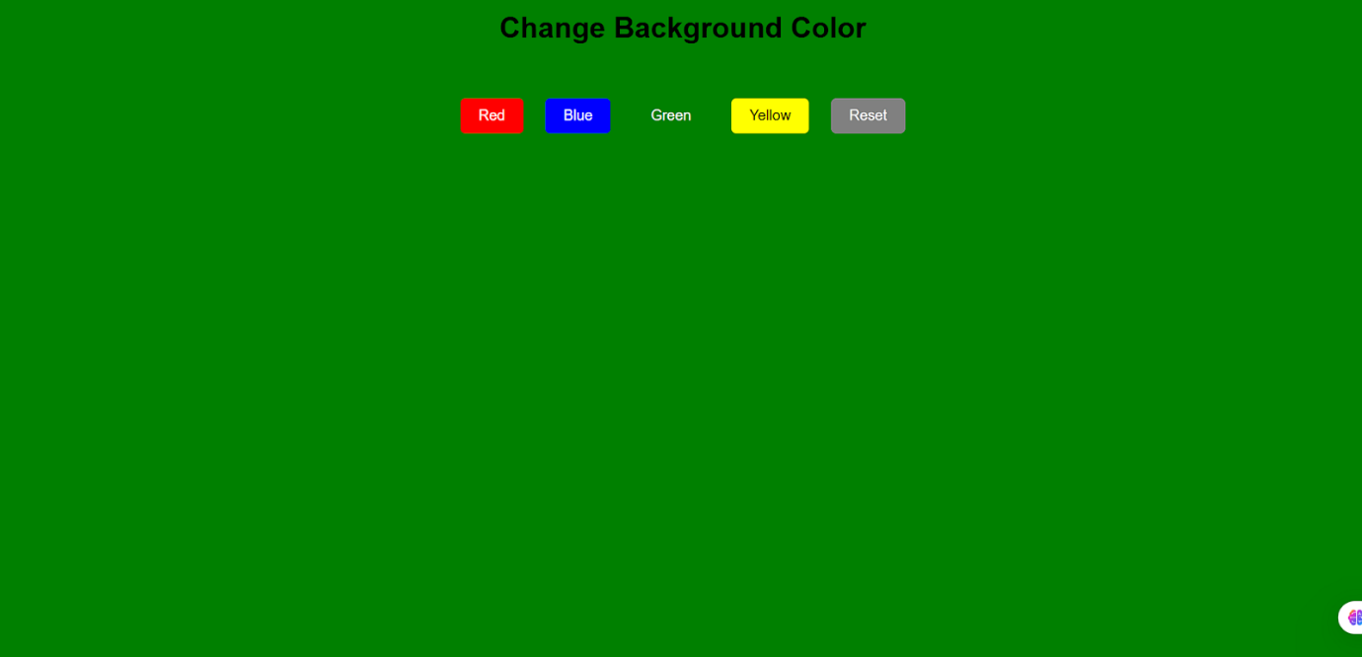

**Program # 10**

Create an HTML page to display a new image and text when the mouse comes over the existing content in the page using JavaScript Event Handling mechanism.

**PROGRAM CODE:**

**Index.html**

<!DOCTYPE html>

<html lang="en">

<head>

    <meta charset="UTF-8">

    <meta name="viewport" content="width=device-width, initial-scale=1.0">

    <title>Image and Text Change on Hover</title>

    <style>

        #container {

            width: 300px;

            height: 200px;

            position: relative;

            margin: 20px auto;

            text-align: center;

        }

        #img1 {

            display: block;

        }

        #img2 {

            display: none;

        }

        #p1, #p2 {

            margin-top: 10px;

            font-size: 18px;

            font-weight: bold;

        }

        #p2 {

            display: none;

        }

    </style>

</head>

<body>

    <h1 style="text-align: center;">Hover Over the Image</h1>

    <p style="text-align: center;">Move your mouse over the image to see the change!</p>

    <div id="container">

        <!-- Working Unsplash image URLs -->

        <img id="img1" src="https://images.unsplash.com/photo-1603415526960-f7e0328c63b1?w=300&h=200&fit=crop" alt="Michael" width="300" height="200">

        <p id="p1">I am Michael.</p>

        <img id="img2" src="https://images.unsplash.com/photo-1599566150163-29194dcaad36?w=300&h=200&fit=crop" alt="Johnny" width="300" height="200">

        <p id="p2">I am Johnny.</p>

    </div>

    <script>

        // Get references to the elements

        const content = document.getElementById('container');

        const image1 = document.getElementById('img1');

        const image2 = document.getElementById('img2');

        const para1 = document.getElementById('p1');

        const para2 = document.getElementById('p2');

        // Add mouseover event listener

        content.addEventListener('mouseover', () => {

            image1.style.display = 'none';

            image2.style.display = 'block';

            para1.style.display = 'none';

            para2.style.display = 'block';

        });

        // Add mouseout event listener

        content.addEventListener('mouseout', () => {

            image2.style.display = 'none';

            image1.style.display = 'block';

            para2.style.display = 'none';

            para1.style.display = 'block';

        });

    </script>

</body>

</html>

**Output**

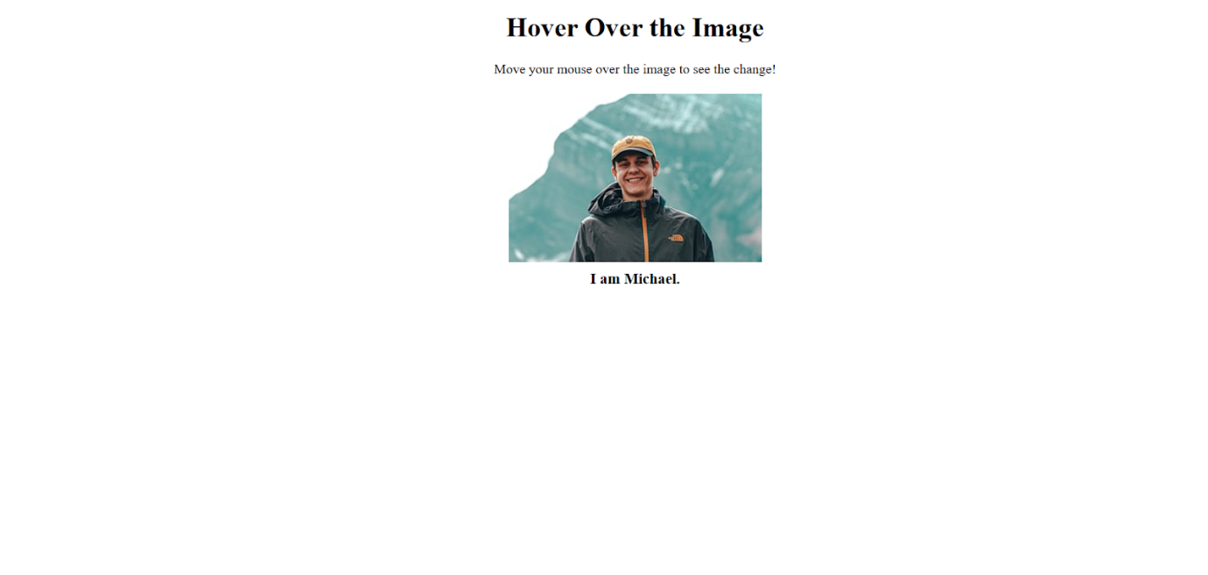

**Program # 11**

Create a HTML registration form and validate the form using JavaScript code. The validation should include the following:  
1. Name validation/Mandatory field validation  
2. password validation  
3. Email validation  
4. Mobile number validation

**PROGRAM CODE:**

**formvalidate.html**

<!DOCTYPE html>

<html lang="en">

<head>

    <meta charset="UTF-8">

    <meta name="viewport" content="width=device-width, initial-scale=1.0">

    <title>Form</title>

     <link href="https://cdn.jsdelivr.net/npm/bootstrap@5.3.3/dist/css/bootstrap.min.css" rel="stylesheet">

</head>

<body>

    <section>

<div class="container-fluid">

    <div class="row">

        <div class="col-md-12">

            <div class="head">

                <h1 class="text-center text-primary">Form Validation</h1>

            </div>

        </div>

    </div>

    <div class="row">

        <div class="col-md-12">

            <div class="formm">

                <form id="myform" action="" method="POST" onsubmit=" return myFormValidate()">

<input type="text" class="form-control my-3" placeholder="Enter Your Name" name="name" id="name" required>

<input type="email" class="form-control my-3" placeholder="Enter Your Email" name="email" id="email">

<input type="text" class="form-control my-3" placeholder="Enter Your Phone No" name="phone" id="phone" maxlength="10" minlength="10" >

<input type="password" class="form-control my-3" placeholder="Enter Your Password" name="password" id="password"  required>

<center><button type="submit" class="btn btn-primary text-center" id="submitBtn" >Submit</button></center>

                </form>

            </div>

        </div>

    </div>

</div>

    </section>

<script>

function myFormValidate(){

let name=document.getElementById("name").value;

let email=document.getElementById("email").value;

let phone=document.getElementById("phone").value;

let password = document.getElementById("password").value;

if(name=="" || email=="" || phone==""){

    alert("All fields are required");

    return false;

}

let emailPattern=/^[a-zA-Z0-9._%+-]+@[a-zA-Z0-9.-]+\.[a-zA-Z]{2,}$/;

if(!emailPattern.test(email)){

    alert("Please enter a valid email address");

    return false;

}

let phonePattern=/^[0-9]{10}$/;

if(!phonePattern.test(phone)){

    alert("Please enter a valid 10-digit phone number");

    return false;

}

let passwordPattern = /^(?=.*[a-z])(?=.*[A-Z])(?=.*\d)(?=.*[@$!%*?&])[A-Za-z\d@$!%*?&]{8,}$/;

if (!passwordPattern.test(password)) {

    alert("Password must be at least 8 characters long, include an uppercase letter, a lowercase letter, a number, and a special character.");

    return false;

}

alert("Registration successful!");

            return true;

}

</script>

     <!-- Bootstrap JS Bundle (includes Popper) -->

    <script src="https://cdn.jsdelivr.net/npm/bootstrap@5.3.3/dist/js/bootstrap.bundle.min.js"></script>

</body>

</body>

</html>

**Output**

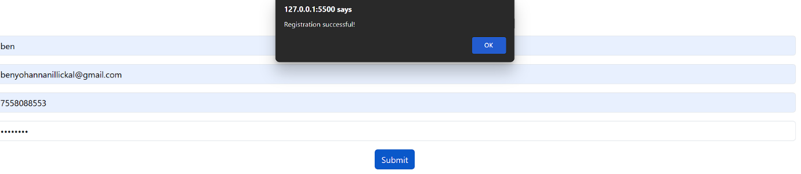

**Program # 12**

Design and develop a complete online exam using Html, CSS and JavaScript. Minimum 4-5 questions should be in the online exam, and the results should be displayed on completion.

**PROGRAM CODE:**

**Exam.html**

<!DOCTYPE html>

<html lang="en">

<head>

    <meta charset="UTF-8">

    <meta name="viewport" content="width=device-width, initial-scale=1.0">

    <title>Online Exam</title>

    <link href="https://cdn.jsdelivr.net/npm/bootstrap@5.3.3/dist/css/bootstrap.min.css" rel="stylesheet">

    <style>

        .question {

            border: 4px solid red;

            background: white;

            padding: 15px;

        }

        .question:hover {

            background: wheat;

            border-color: black;

            border-radius: 15px;

        }

        .answer {

            margin-top: 10px;

        }

        #score {

            font-size: 24px;

            font-weight: bold;

            color: green;

            margin-top: 20px;

        }

    </style>

</head>

<body>

<section>

<div class="container-fluid">

    <div class="row">

        <div class="col-md-12">

            <div class="exmt text-center">

                <h1>Web Programming Quiz</h1>

            </div>

        </div>

        <form id="exam" method="POST" onsubmit="return checkExam()">

            <div class="row">

                <div class="col-md-12">

                    <!-- Question 1 -->

                    <div class="question form-control my-3">

                        <h6 id="q1">1. Full Form of HTML</h6>

                        <div class="answer">

                            <input type="radio" name="q1" id="q1a" value="Hyper Text Markup Language" required>

                            <label for="q1a">Hyper Text Markup Language</label>

                        </div>

                        <div class="answer">

                            <input type="radio" name="q1" id="q1b" value="High Text Markup Language">

                            <label for="q1b">High Text Markup Language</label>

                        </div>

                        <div class="answer">

                            <input type="radio" name="q1" id="q1c" value="Hyperlinks and Text Markup Language">

                            <label for="q1c">Hyperlinks and Text Markup Language</label>

                        </div>

                        <div class="answer">

                            <input type="radio" name="q1" id="q1d" value="None of the above">

                            <label for="q1d">None of the above</label>

                        </div>

                    </div>

                    <!-- Question 2 -->

                    <div class="question form-control my-3">

                        <h6 id="q2">2. What does CSS stand for?</h6>

                        <div class="answer">

                            <input type="radio" name="q2" id="q2a" value="Cascading Style Sheets" required>

                            <label for="q2a">Cascading Style Sheets</label>

                        </div>

                        <div class="answer">

                            <input type="radio" name="q2" id="q2b" value="Creative Style Sheets">

                            <label for="q2b">Creative Style Sheets</label>

                        </div>

                        <div class="answer">

                            <input type="radio" name="q2" id="q2c" value="Computer Style Sheets">

                            <label for="q2c">Computer Style Sheets</label>

                        </div>

                        <div class="answer">

                            <input type="radio" name="q2" id="q2d" value="Colorful Style Sheets">

                            <label for="q2d">Colorful Style Sheets</label>

                        </div>

                    </div>

                    <!-- Question 3 -->

                    <div class="question form-control my-3">

                        <h6 id="q3">3. Which HTML tag is used to create a hyperlink?</h6>

                        <div class="answer">

                            <input type="radio" name="q3" id="q3a" value="<a>" required>

                            <label for="q3a">&lt;a&gt;</label>

                        </div>

                        <div class="answer">

                            <input type="radio" name="q3" id="q3b" value="<link>">

                            <label for="q3b">&lt;link&gt;</label>

                        </div>

                        <div class="answer">

                            <input type="radio" name="q3" id="q3c" value="<href>">

                            <label for="q3c">&lt;href&gt;</label>

                        </div>

                        <div class="answer">

                            <input type="radio" name="q3" id="q3d" value="<url>">

                            <label for="q3d">&lt;url&gt;</label>

                        </div>

                    </div>

                    <!-- Question 4 -->

                    <div class="question form-control my-3">

                        <h6 id="q4">4. Which property is used in CSS to change the text color?</h6>

                        <div class="answer">

                            <input type="radio" name="q4" id="q4a" value="color" required>

                            <label for="q4a">color</label>

                        </div>

                        <div class="answer">

                            <input type="radio" name="q4" id="q4b" value="font-color">

                            <label for="q4b">font-color</label>

                        </div>

                        <div class="answer">

                            <input type="radio" name="q4" id="q4c" value="text-color">

                            <label for="q4c">text-color</label>

                        </div>

                        <div class="answer">

                            <input type="radio" name="q4" id="q4d" value="background-color">

                            <label for="q4d">background-color</label>

                        </div>

                    </div>

                    <!-- Question 5 -->

                    <div class="question form-control my-3">

                        <h6 id="q5">5. Which HTML element is used to display an image?</h6>

                        <div class="answer">

                            <input type="radio" name="q5" id="q5a" value="<img>" required>

                            <label for="q5a">&lt;img&gt;</label>

                        </div>

                        <div class="answer">

                            <input type="radio" name="q5" id="q5b" value="<image>">

                            <label for="q5b">&lt;image&gt;</label>

                        </div>

                        <div class="answer">

                            <input type="radio" name="q5" id="q5c" value="<src>">

                            <label for="q5c">&lt;src&gt;</label>

                        </div>

                        <div class="answer">

                            <input type="radio" name="q5" id="q5d" value="<picture>">

                            <label for="q5d">&lt;picture&gt;</label>

                        </div>

                    </div>

                </div>

            </div>

            <div class="text-center mb-4">

                <button type="submit" class="btn btn-primary">Submit</button>

            </div>

        </form>

        <div id="score" class="text-center mt-4"></div>

    </div>

</div>

</section>

<script>

function checkExam() {

    let score = 0;

    let ans1 = document.querySelector('input[name="q1"]:checked')?.value;

    let ans2 = document.querySelector('input[name="q2"]:checked')?.value;

    let ans3 = document.querySelector('input[name="q3"]:checked')?.value;

    let ans4 = document.querySelector('input[name="q4"]:checked')?.value;

    let ans5 = document.querySelector('input[name="q5"]:checked')?.value;

    if (ans1 === "Hyper Text Markup Language") score++;

    if (ans2 === "Cascading Style Sheets") score++;

    if (ans3 === "<a>") score++;

    if (ans4 === "color") score++;

    if (ans5 === "<img>") score++;

    document.getElementById('score').innerHTML = `<h3>Your score is: ${score} / 5</h3>`;

    // Disable all radio buttons

    const radioButtons = document.querySelectorAll('input[type="radio"]');

    radioButtons.forEach((radio) => {

        radio.disabled = true;

    });

    return false;

}

</script>

<!-- Bootstrap JS Bundle (includes Popper) -->

<script src="https://cdn.jsdelivr.net/npm/bootstrap@5.3.3/dist/js/bootstrap.bundle.min.js"></script>

</body>

</html>

**Output**

**Lab Cycle 3**

**CO3: Create functional components using both client-side and server-side**

**scripting to support dynamic web behaviour.**

**Program # 13**

Build a PHP code to store name of students in an array and display it using print_r function. Sort and display the same using asort & arsort functions.

**PROGRAM CODE:**

**Arrayphp.php**

<?php

$students = ["John", "Alice", "Bob", "Diana", "Charlie"];

echo "Original Array:\n";

print_r($students);

echo "\n";

asort($students);

echo "\nArray Sorted in Ascending Order (asort):\n";

print_r($students);

arsort($students);

echo "\nArray Sorted in Descending Order (arsort):\n";

print_r($students);

?>

**Output**

Original Array: Array ( [0] => John [1] => Alice [2] => Bob [3] => Diana [4] => Charlie )

 Array Sorted in Ascending Order (asort): Array ( [1] => Alice [2] => Bob [4] => Charlie [3] => Diana [0] => John ) Array Sorted in Descending Order (arsort): Array ( [0] => John [3] => Diana [4] => Charlie [2] => Bob [1] => Alice )

**Program # 14**

Build a PHP code to store name of Indian Cricket players in an array and display the same in HTML table.

**PROGRAM CODE:**

**Crickerarray.php**

<?php

$cricketers = ["Sachin Tendulkar", "Virat Kohli", "MS Dhoni", "Brian Lara", "Jacques Kallis"];

?>

<html>

<head>

    <title>Cricketers Array</title>

</head>

<body>

<table border="1" cellpadding="10" cellspacing="0">

    <tr><th>Si No.</th>

    <th>Cricketers Name</th></tr>

    <?php

    $count=1;

    foreach ($cricketers as $cricketer) {

        echo "<tr><td>$count</td>";

        echo "<td>$cricketer</td></tr>";

        $count++;

    }

    ?>

</table>

</body>

</html>

**Output**

**Program # 15**

Design a registration form in HTML, and do necessary server side validations using PHP.

**PROGRAM CODE:**

**Formvalidate.php**

<?php

if ($_SERVER['REQUEST_METHOD'] == 'POST') {

    $name = htmlspecialchars($_POST['name']);

    $email = htmlspecialchars($_POST['email']);

    $age = htmlspecialchars($_POST['age']);

    $password = htmlspecialchars($_POST['password']);

    $passwordValid = preg_match('/^(?=.*[A-Za-z])(?=.*\d)(?=.*[^A-Za-z0-9]).+$/', $password);

 if (!empty($name) && !empty($email) && !empty($age) && !empty($password)) {

        if (!filter_var($email, FILTER_VALIDATE_EMAIL)) {

            echo "<div class='alert alert-danger text-center' role='alert'>Invalid email format.</div>";

        }

        elseif (!$passwordValid) {

            echo "<div class='alert alert-danger text-center' role='alert'>

                    Password must be alphanumeric and include at least one symbol.

                  </div>";

        }

        else {

            echo "<div class='alert alert-success text-center' role='alert'>

                    Form submitted successfully!<br>

                    Name: $name<br>

                    Email: $email<br>

                    Age: $age

                  </div>";

        }

    }

    else {

        echo "<div class='alert alert-danger text-center' role='alert'>

                Please fill in all fields.

              </div>";

    }

}

?>

<!DOCTYPE html>

<html lang="en">

<head>

    <meta charset="UTF-8">

    <meta name="viewport" content="width=device-width, initial-scale=1.0">

    <title>Form</title>

    <!-- Bootstrap CSS -->

    <link href="https://cdn.jsdelivr.net/npm/bootstrap@5.3.0/dist/css/bootstrap.min.css" rel="stylesheet">

</head>

<body>

    <section>

    <div class="container-fluid">

        <div class="row justify-content-center">

            <div class="col-md-6">

                <h2 class="text-center my-4">User Information Form</h2>

                <form action="<?php echo $_SERVER['PHP_SELF']; ?>" method="POST" class="border p-4 bg-light">

                    <div class="mb-3">

                        <label for="name" class="form-label">Name</label>

                        <input type="text" class="form-control" id="name" name="name">

                    </div>

                    <div class="mb-3">

                        <label for="email" class="form-label">Email</label>

                        <input type="email" class="form-control" id="email" name="email">

                    </div>

                    <div class="mb-3">

                        <label for="age" class="form-label">Age</label>

                        <input type="number" class="form-control" id="age" name="age">

                    </div>

                    <div class="mb-3">

                        <label for="password" class="form-label">Password</label>

                        <input type="password" class="form-control" id="password" name="password">

                    </div>

                    <button type="submit" class="btn btn-primary w-100">Submit</button>

                </form>

            </div>

        </div>

    </div>

  </section>

    <!-- Bootstrap JavaScript Bundle -->

    <script src="https://cdn.jsdelivr.net/npm/bootstrap@5.3.0/dist/js/bootstrap.bundle.min.js"></script>

</body>

</html>

**Output**

**Program # 16**

Develop a user-friendly electricity bill calculator using HTML and PHP. Collect the consumer data, and the units used, through an input form. Based on the given tariff, calculate the consumer bill amount.

**Tariff:**  
Rate of electricity  for 1-100 units: Rs.5/unit  
Rate of electricity from 101 units  to 200 units: Rs. 7.5/unit  
Rate of electricity from 201 units: Rs.10/unit.

**PROGRAM CODE:**

**Electricity.php**

<?php

 if($_SERVER["REQUEST_METHOD"] == "POST"){

    $name = htmlspecialchars($_POST['name']);

    $customerId = htmlspecialchars($_POST['id']);

    $units = htmlspecialchars($_POST['units']);

    $billAmount = 0;

  if($units <= 100){

    $billAmount = $units * 5;

  }

  elseif($units <= 200){

    $billAmount = (100 * 5) + (($units - 100) * 7);

  }

  elseif($units >=201){

    $billAmount = (100 * 5) + (100 * 7) + (($units - 200) * 10);

  }

}

  if(isset($billAmount)){

    echo "<div class='alert alert-success text-center' role='alert'>

            Electricity Bill Details:<br>

            Name: $name<br>

            Customer ID: $customerId<br>

            Units Consumed: $units<br>

            Total Bill Amount: ₹$billAmount

          </div>";

    }

?>

<!DOCTYPE html>

<html lang="en">

<head>

    <meta charset="UTF-8">

    <meta name="viewport" content="width=device-width, initial-scale=1.0">

    <title>Electricty</title>

    <!-- Bootstrap CSS -->

    <link href="https://cdn.jsdelivr.net/npm/bootstrap@5.3.0/dist/css/bootstrap.min.css" rel="stylesheet">

</head>

<body>

    <section>

   <div class="container">

    <div class="row justify-content-center">

        <div class="col-md-12">

          <div class="title">

            <h2 class="text-center mt-4">Electricity Bill Calculator</h2>

          </div>

        </div>

    </div>

    <div class="row justify-content-center">

      <div class="col-md-6">

        <form action="<?php echo $_SERVER['PHP_SELF'];?>" method="POST" class="border p-4 bg-light">

         <div class="mb-3">

            <label for="name" class="form-label">Enter Your Name</label>

            <input type="text" class="form-control" id="name" name="name" required>

         </div>

         <div class="mb-3">

            <label for="id" class="form-label">Enter Your Customer ID</label>

            <input type="text" class="form-control" id="id" name="id" required>

         </div>

         <div class="mb-3">

            <label for="units" class="form-label">Enter Units Consumed</label>

            <input type="number" class="form-control" id="units" name="units" required>

          </div>

          <button type="submit" class="btn btn-primary w-100">Calculate Bill</button>

        </form>

      </div>

    </div>

   </div>

    </section>

    <!-- Bootstrap JavaScript Bundle -->

    <script src="https://cdn.jsdelivr.net/npm/bootstrap@5.3.0/dist/js/bootstrap.bundle.min.js"></script>

</body>

</html>

**Output**

**Lab Cycle 4**

**CO4: Develop programs to link front-end interfaces with back-end databases to enable data storage, retrieval, and processing.**

**Program # 17**

Develop a PHP program to connect to a database and retrieve data from a table and show the details in a neat format.

**PROGRAM CODE:**

**Studentdetailsshow.php**

<?php

$servername = "localhost";

$username = "root";

$password = "";

$dbname = "exam";

$conn = new mysqli($servername, $username, $password, $dbname);

if (!$conn) {

    die("Connection failed: " . $conn->connect_error);

}

$sql = "SELECT * FROM student";

$result = mysqli_query($conn, $sql);

?>

<!DOCTYPE html>

<html lang="en">

<head>

    <meta charset="UTF-8">

    <meta name="viewport" content="width=device-width, initial-scale=1.0">

    <title>Student Details</title>

    <!-- Bootstrap CSS -->

    <link href="https://cdn.jsdelivr.net/npm/bootstrap@5.3.0/dist/css/bootstrap.min.css" rel="stylesheet">

</head>

<body>

    <div class="container mt-5">

        <h2 class="text-center mb-4">Student Details</h2>

        <table class="table table-bordered table-striped">

            <thead class="table-dark">

                <tr>

                    <th>Roll No</th>

                    <th>Name</th>

                    <th>Email</th>

                    <th>Phone</th>

                </tr>

            </thead>

            <tbody>

                <?php

                if (mysqli_num_rows($result)> 0) {

                    while ($row = mysqli_fetch_assoc($result)) {

                        echo "<tr>

                                <td>" . $row['rollno'] . "</td>

                                <td>" . $row['name'] . "</td>

                                <td>" . $row['email'] . "</td>

                                <td>" . $row['phone'] . "</td>

                              </tr>";

                    }

                } else {

                    echo "<tr><td colspan='4' class='text-center'>No records found</td></tr>";

                }

                ?>

            </tbody>

        </table>

    </div>

    <?php $conn->close(); ?>

    <!-- Bootstrap JavaScript Bundle -->

    <script src="https://cdn.jsdelivr.net/npm/bootstrap@5.3.0/dist/js/bootstrap.bundle.min.js"></script>

</body>

</html>

**Output**

**Program # 18**

Develop an application in PHP and MySQL, to accept book details viz. Book id, title, authors, edition and publisher from an HTML form in a web page and save the records in a MySQL database on submission. The program also should include a search function given the author's name, and display the search results.

**PROGRAM CODE:**

**Book.php**

<?php

$server = "localhost";

$user = "root";

$pass = "";

$dbname = "exam";

$conn = mysqli_connect($server, $user, $pass, $dbname);

if (!$conn) {

    die("Database Connection Failed: " . $conn->connect_error);

}

$message = "";

// INSERT BOOK RECORD

if (isset($_POST['submit'])) {

    $bookno = $_POST['bookno'];

    $name = $_POST['name'];

    $author = $_POST['author'];

    $edition = $_POST['edition'];

    $publisher = $_POST['publisher'];

   if (!empty($bookno) && !empty($name) && !empty($author) && !empty($edition) && !empty($publisher)) {

        $sql = "INSERT INTO book (bookno, name, author, edition, publisher)

                VALUES ('$bookno', '$name', '$author', '$edition', '$publisher')";

      if (mysqli_query($conn, $sql)) {

           $message = "

    <div class='alert alert-success text-center'>

        <strong>Book added successfully!</strong><br>

        <b>Book No:</b> $bookno <br>

        <b>Title:</b> $name <br>

        <b>Author:</b> $author <br>

        <b>Edition:</b> $edition <br>

        <b>Publisher:</b> $publisher

    </div>";

        } else {

            $message = "<div class='alert alert-danger text-center'>Error: Book No already exists or invalid data.</div>";

        }

    } else {

        $message = "<div class='alert alert-danger text-center'>All fields are required.</div>";

    }

}

// SEARCH BY AUTHOR

if (isset($_POST['search'])) {

    $searchno = $_POST['bookno'];

     $sqls="SELECT * FROM book WHERE bookno='$searchno'";

    $result = mysqli_query($conn, $sqls);

}

?>

<!DOCTYPE html>

<html lang="en">

<head>

    <meta charset="UTF-8">

    <title>Book Information</title>

    <link href="https://cdn.jsdelivr.net/npm/bootstrap@5.3.0/dist/css/bootstrap.min.css" rel="stylesheet">

</head>

<body>

<div class="container mt-4">

    <h2 class="text-center">Book Entry Form</h2>

    <?php echo $message; ?>

    <form method="POST" action="<?php echo $_SERVER['PHP_SELF'];  ?>" class="border p-4 bg-light">

        <div class="mb-3">

            <label class="form-label">Book No</label>

            <input type="number" name="bookno" class="form-control">

        </div>

        <div class="mb-3">

            <label class="form-label">Book Title</label>

            <input type="text" name="name" class="form-control">

        </div>

        <div class="mb-3">

            <label class="form-label">Author</label>

            <input type="text" name="author" class="form-control">

        </div>

        <div class="mb-3">

            <label class="form-label">Edition</label>

            <input type="text" name="edition" class="form-control">

        </div>

        <div class="mb-3">

            <label class="form-label">Publisher</label>

            <input type="text" name="publisher" class="form-control">

        </div>

        <button type="submit" name="submit" class="btn btn-primary w-100">Add Book</button>

    </form>

    <hr class="my-4">

    <h2 class="text-center">Search Books by Book No</h2>

    <form method="POST"   action="<?php echo $_SERVER['PHP_SELF'];  ?>" class="border p-4 bg-light mb-4">

        <div class="mb-3">

            <label class="form-label">Author Name</label>

            <input type="text" name="bookno" class="form-control">

        </div>

        <button type="submit" name="search" class="btn btn-success w-100">Search</button>

    </form>

    <!-- DISPLAY SEARCH RESULTS -->

    <?php

    if (isset($_POST['search'])) {

        echo "<h4>Search Results:</h4>";

        if (mysqli_num_rows($result) > 0) {

            echo "<table class='table table-bordered table-striped text-center'>

                    <thead class='table-dark'>

                        <tr>

                            <th>Book No</th>

                            <th>Title</th>

                            <th>Author</th>

                            <th>Edition</th>

                            <th>Publisher</th>

                        </tr>

                    </thead>

                    <tbody>";

            while ($row = mysqli_fetch_assoc($result)) {

                echo "<tr>

                        <td>{$row['bookno']}</td>

                        <td>{$row['name']}</td>

                        <td>{$row['author']}</td>

                        <td>{$row['edition']}</td>

                        <td>{$row['publisher']}</td>

                      </tr>";

            }

            echo "</tbody></table>";

        } else {

            echo "<div class='alert alert-warning'>No books found for this author.</div>";

        }

    }

   ?>

</div>

</body>

</html>

<?php

$conn->close();

?>

**Output**



